Dr INDIRA M.S.
Prof and head Dept of EEE
Sir MVIT
Subject: Basic Electrical Sciences
Chapter Domestic Wiring

DOMESTIC WIRING

In this chapter you gain to understand the following:

- Electrical domestic wiring
- Types of wiring
  - Suitability of a particular wiring system for a given installation
- Corridor and staircase lighting
- Necessity of earthing
  - Different types of earthing
- Fuses
  - Different types of fuses
- Working of a fluorescent lamp and sodium vapor lamp

Introduction
A network of wires drawn connecting the meter board to the various energy consuming loads (lamps, fans, motors etc) through control and protective devices for efficient distribution of power is known as electrical wiring.
Electrical wiring done in residential and commercial buildings to provide power for lights, fans, pumps and other domestic appliances is known as domestic wiring. There are several wiring systems in practice. They can be classified into:

- Tree system - In this system branches are tapped from the main circuit at required points. This involves many joints making the location of the fault point difficult.
Though the method is economical it is visually unappealing with scattered fuses and is affected by large voltage drops.

- Distribution system - This system is more organized in the sense that the main circuit is drawn to several distribution centers and connected to the distribution boards. Branches are tapped from these distribution boards. This system of wiring has an aesthetic appeal, as they are without joints and also makes the location of the fault point easier. All the points are maintained almost at the same potential. Each circuit is provided with an independent fuse. Provides flexibility for repair and maintenance. This system is widely preferred for indoor wiring though expensive.

  - Types of Wiring:

- Cleat wiring
- CTS wiring or TRS wiring or batten wiring
- Metal sheathed wiring or lead sheathed wiring
- Casing and capping
- Conduit wiring

1. Cleat wiring:

In this type of wiring, insulated conductors (usually VIR, Vulcanized Indian Rubber) are supported on porcelain or wooden cleats. The cleats have two halves one base and the other cap. The cables are placed in the grooves provided in the base and then the cap is placed. Both are fixed securely on the walls by 40mm long screws. The cleats are easy to erect and are fixed 4.5 – 15 cms apart. This wiring is suitable for temporary installations where cost is the main criteria but not the appearance.

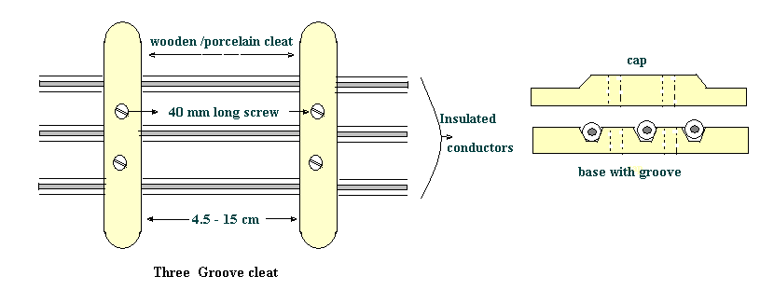

Advantages:

- Easy installation
- Materials can be retrieved for reuse
- Flexibility provided for inspection, modifications and expansion.
- Relatively economical
- Skilled manpower not required.

Disadvantages:

- Appearance is not good
- Open system of wiring requiring regular cleaning.
- Higher risk of mechanical injury.

2. CTS ( Cable Tyre Sheathed) / TRS ( Tough Rubber Sheathed )
/ Batten wiring:

In this wiring system, wires sheathed in tough rubber are used which are quite flexible. They are clipped on wooden battens with brass clips (link or joint) and fixed on to the walls or ceilings by flat head screws. These cables are moisture and chemical proof. They are suitable for damp climate but not suitable for outdoor use in sunlight. TRS wiring is suitable for lighting in low voltage installations

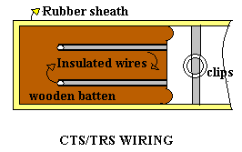
Advantages:
- Easy installation and is durable
- Lower risk of short circuit.
- Cheaper than casing and capping system of wiring
- Gives a good appearance if properly erected.

Disadvantages:
- Danger of mechanical injury.
- Danger of fire hazard.
- Should not be exposed to direct sunlight.
- Skilled workmen are required.

3. Metal Sheathed or Lead Sheathed wiring :

The wiring is similar to that of CTS but the conductors (two or three) are individually insulated and covered with a common outer lead-aluminum alloy sheath. The sheath protects the cable against dampness, atmospheric extremities and mechanical damages. The sheath is earthed at every junction to provide a path to ground for the leakage current. They are fixed by means of metal clips on wooden battens. The wiring system is very expensive. It is suitable for low voltage installations.

Precautions to be taken during installation
- The clips used to fix the cables on battens should not react with the sheath.
- Lead sheath should be properly earthed to prevent shocks due to leakage currents.
- Cables should not be run in damp places and in areas where chemicals (may react with the lead) are used.

Advantages:
- Easy installation and is aesthetic in appearance.
- Highly durable
- Suitable in adverse climatic conditions provided the joints are not exposed

Disadvantages:
- Requires skilled labor
- Very expensive
- Unsuitable for chemical industries

4. Casing and Capping:

It consists of insulated conductors laid inside rectangular, teakwood or PVC boxes having grooves inside it. A rectangular strip of wood called capping having same width as that of casing is fixed over it. Both the casing and the capping are screwed together at every 15 cms. Casing is attached to the wall. Two or more wires of same polarity are drawn through different grooves. The system is suitable for indoor and domestic installations.

Advantages:
- Cheaper than lead sheathed and conduit wiring.
- Provides good isolation as the conductors are placed apart reducing the risk of short circuit.
- Easily accessible for inspection and repairs.
- Since the wires are not exposed to atmosphere, insulation is less affected by dust, dirt and climatic variations.

Disadvantages:
- Highly inflammable.
- Usage of unseasoned wood gets damaged by termites.
- Skilled workmanship required.

5. Conduit wiring:

In this system PVC (polyvinyl chloride) or VIR cables are run through metallic or PVC pipes providing good protection against mechanical injury and fire due to short circuit. They are either embedded inside the walls or supported over the walls, and are known as concealed wiring or surface conduit wiring (open conduit) respectively. The conduits are buried inside the walls on wooden gutties and the wires are drawn through them with fish (steel) wires. The system is best suited for public buildings, industries and workshops.
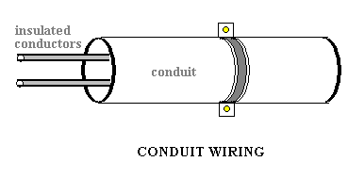
Advantages:
- No risk of fire and good protection against mechanical injury.
- The lead and return wires can be carried in the same tube.
- Earthing and continuity is assured.
- Waterproof and trouble shooting is easy.
- Shock- proof with proper earthing and bonding
- Durable and maintenance free
- Aesthetic in appearance

Disadvantages:
- Very expensive system of wiring.
- Requires good skilled workmanship.
- Erection is quiet complicated and is time consuming.
- Risk of short circuit under wet conditions (due to condensation of water in tubes).

- FACTORS AFFECTING THE CHOICE OF WIRING SYSTEM:

The choice of wiring system for a particular installation depends on technical factors and economic viability.

- Durability: Type of wiring selected should conform to standard specifications, so that it is durable i.e. without being affected by the weather conditions, fumes etc.
- Safety: The wiring must provide safety against leakage, shock and fire hazards for the operating personnel.
3. Appearance: Electrical wiring should give an aesthetic appeal to the
interiors.

4. Cost: It should not be prohibitively expensive.
5. Accessibility: The switches and plug points provided should be easily accessible. There must be provision for further extension of the wiring system, if necessary.
- Maintenance Cost: The maintenance cost should be a minimum
7. Mechanical safety: The wiring must be protected against any mechanical damage

  - Specification of Wires:

The conductor material, insulation, size and the number of cores, specifies the electrical wires. These are important parameters as they determine the current and voltage handling capability of the wires. The conductors are usually of either copper or aluminum. Various insulating materials like PVC, TRS, and VIR are used. The wires may be of single strand or multi strand. Wires with combination of different diameters and the number of cores or strands are available.
For example: The VIR conductors are specified as 1/20, 3/22,….7/20 ………
The numerator indicates the number of strands while the denominator corresponds to the diameter of the wire in SWG (Standard Wire Gauge). SWG 20 corresponds to a wire of diameter 0.914mm, while SWG 22 corresponds to a wire of diameter 0.737 mm.
A 7/0 wire means, it is a 7-cored wire of diameter 12.7mm (0.5 inch). The selection of the wire is made depending on the requirement considering factors like current and voltage ratings, cost and application.
Example: Application: domestic wiring
- Lighting - 3/20 copper wire
- Heating - 7/20 copper wire
The enamel coating (on the individual strands) mutually insulates the strands and the wire on the whole is provided with PVC insulation. The current carrying capacity depends on the total area of the wire. If cost is the criteria then aluminum conductors are preferred. In that case, for the same current rating much larger diameter of wire is to be used.

- Two- way and Three- way Control of Lamps:

The domestic lighting circuits are quite simple and they are usually controlled from one point. But in certain cases it might be necessary to control a single lamp from more than one point (Two or Three different points).
For example: staircases, long corridors, large halls etc.

- Two-way Control of lamp:

Two-way control is usually used for staircase lighting. The lamp can be controlled from two different points: one at the top and the other at the bottom - using two- way switches which strap wires interconnect. They are also used in bedrooms, big halls and large corridors. The circuit is shown in the following figure.

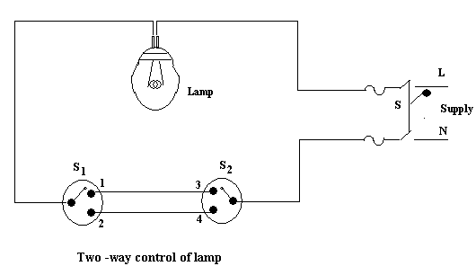
Switches S₁ and S₂ are two-way switches with a pair of terminals 1&2, and 3&4 respectively. When the switch S₁ is in position1 and switch S₂ is in position 4, the circuit does not form a closed loop and there is no path for the current to flow and hence the lamp will be OFF. When S₁ is changed to position 2 the circuit gets completed and hence the lamp glows or is ON. Now if S₂ is changed to position 3 with S₁ at position 2 the circuit continuity is broken and the lamp is off. Thus the lamp can be controlled from two different points.

Position of S1 | Position of S2 | Condition of lamp
1 | 3 | ON
1 | 4 | OFF
2 | 3 | OFF
2 | 4 | ON

Animation Instruction: The lamp to be made ON or OFF depending on the position of the switches S₁ and S_{2.} and the corresponding entry in the table to be highlighted along with the flow of current in the circuit. Current to flow when the circuit is complete and no flow of current indicated when the circuit is incomplete.

- Three- way Control of lamp:

In case of very long corridors it may be necessary to control the lamp from 3 different points. In such cases, the circuit connection requires two; two-way switches S₁and S₂ and an intermediate switch S₃. An intermediate switch is a combination of two, two way switches coupled together. It has 4 terminals ABCD. It can be connected in two ways

a) Straight connection
b) Cross connection
In case of straight connection, the terminals or points AB and CD are connected as shown in figure 1(a) while in case of cross connection, the terminals AB and
C D is connected as shown in figure 1(b). As explained in two –way control the lamp is ON if the circuit is complete and is OFF if the circuit does not form a closed loop.

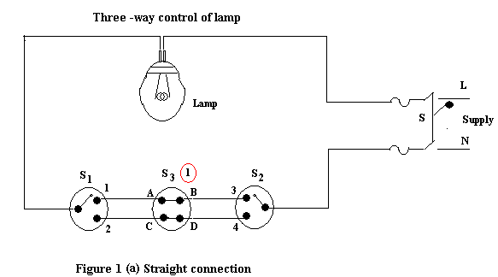

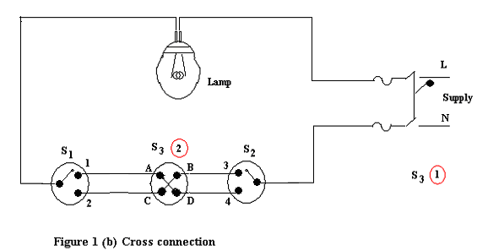

Animation Instruction: The lamp to be made ON or OFF depending on the position of the switches S₁ S_{2.} & S₃ and the corresponding entry in the table to be highlighted for both straight and cross connection. . Current to flow when the circuit is complete and no flow of current indicated when the circuit is incomplete.

The condition of the lamp is given in the table depending on the positions of the switches S₁, S₂ and S_{3.}

Position of S3 | Position of S1 | Position of S2 | Condition of the lamp
1  Straight connection | 1  1  2  2 | 3  4  3  4 | ON  OFF  OFF  ON
2  Cross connection | 1  1  2  2 | 3  4  3  4 | OFF  ON  ON  OFF

- Earthing:
The potential of the earth is considered to be at zero for all practical purposes as the generator (supply) neutral is always earthed. The body of any electrical equipment is connected to the earth by means of a wire of negligible resistance to safely discharge electric energy, which may be due to failure of the insulation, line coming in contact with the casing etc. Earthing brings the potential of the body of the equipment to ZERO i.e. to the earth’s potential, thus protecting the operating personnel against electrical shock. The body of the electrical equipment is not connected to the supply neutral because due to long transmission lines and intermediate substations, the same neutral wire of the generator will not be available at the load end. Even if the same neutral wire is running it will have a self-resistance, which is higher than the human body resistance. Hence, the body of the electrical equipment is connected to earth only.
Thus earthing is to connect any electrical equipment to earth with a very low resistance wire, making it to attain earth’s potential. The wire is usually connected to a copper plate placed at a depth of 2.5 to 3meters from the ground level.

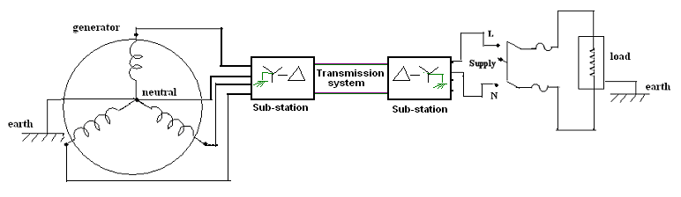
BLOCK DIAGRAM

The earth resistance is affected by the following factors:
- Material properties of the earth wire and the electrode
- Temperature and moisture content of the soil
- Depth of the pit
- Quantity of the charcoal used

The importance of earthing is illustrated in the following figures
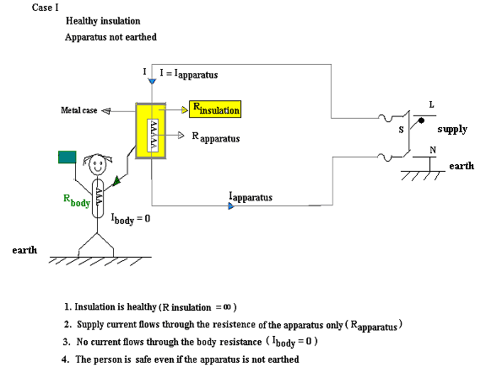
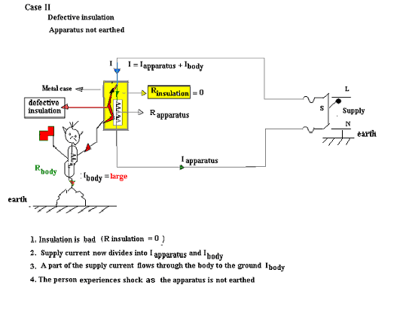

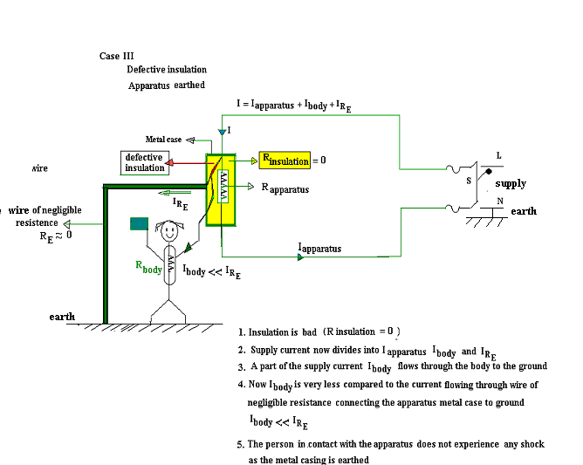

Animation Instruction: When the supply switch S is closed in Case I current flows only through the healthy apparatus. No current flows through the person and does not experience a shock.

Case II
When the supply switch S is closed with defective insulation and apparatus not earthed, a part of the current flows through the body and the person
experiences electrical shock.

Case III
When the supply switch S is closed with Defective insulation and apparatus being earthed though a small part of the current flows through the body the person will not experience a shock.

- Necessity of Earthing:
- To protect the operating personnel from danger of shock in case they come in contact with the charged frame due to defective insulation.
- To maintain the line voltage constant under unbalanced load condition.
- Protection of the equipments
- Protection of large buildings and all machines fed from overhead lines against lightning.

  - Methods of Earthing:
The important methods of earthing are the plate earthing and the pipe earthing. The earth resistance for copper wire is 1 ohm and that of G I wire less than 3 ohms. The earth resistance should be kept as low as possible so that the neutral of any electrical system, which is earthed, is maintained almost at the earth potential. The typical value of the earth resistance at powerhouse is 0. 5 ohm and that at substation is 1 ohm.

- Plate earthing
- Pipe earthing

  - Plate Earthing

In this method a copper plate of 60cm x 60cm x 3.18cm or a GI plate of the size 60cm x 60cm x 6.35cm is used for earthing. The plate is placed vertically down inside the ground at a depth of 3m and is embedded in alternate layers of coal and salt for a thickness of 15 cm. In addition, water is poured for keeping the earth electrode resistance value well below a maximum of 5 ohms. The earth wire is securely bolted to the earth plate. A cement masonry chamber is built with a cast iron cover for easy regular maintenance.

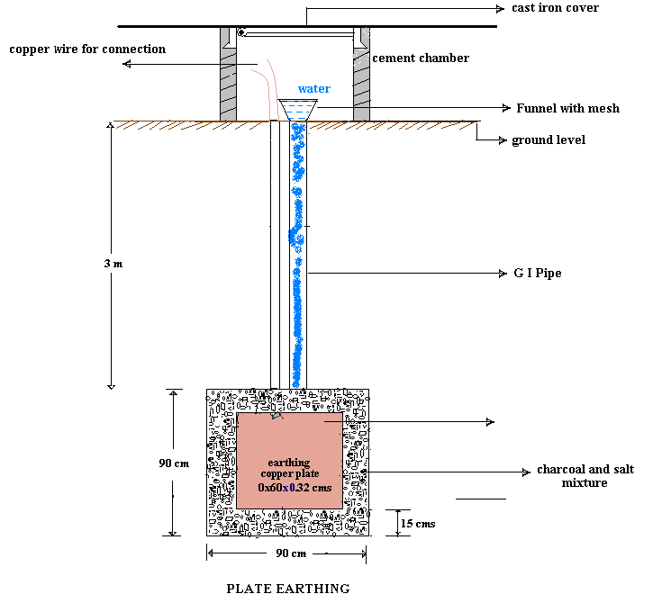

- Pipe Earthing

Earth electrode made of a GI (galvanized) iron pipe of 38mm in diameter and length of 2m (depending on the current) with 12mm holes on the surface is placed upright at a depth of 4.75m in a permanently wet ground. To keep the value of the earth resistance at the desired level, the area (15 cms) surrounding the GI pipe is filled with a mixture of salt and coal.. The efficiency of the earthing system is improved by pouring water through the funnel periodically. The GI earth wires of sufficient cross- sectional area are run through a 12.7mm diameter pipe (at 60cms below) from the 19mm diameter pipe and secured tightly at the top as shown in the following figure.

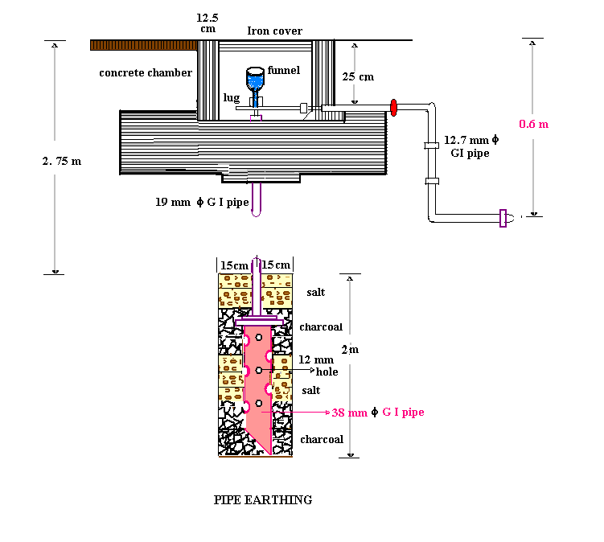

When compared to the plate earth system the pipe earth system can carry larger leakage currents as a much larger surface area is in contact with the soil for a given electrode size. The system also enables easy maintenance as the earth wire connection is housed at the ground level.

- PROTECTIVE DEVICES

Protection for electrical installation must be provided in the event of faults such as short circuit, overload and earth faults. The protective circuit or device must be fast acting and isolate the faulty part of the circuit immediately. It also helps in isolating only required part of the circuit without affecting the remaining circuit during maintenance. The following devices are usually used to provide the necessary protection:
  - Fuses
  - Relays
  - Miniature circuit breakers (MCB)
  - Earth leakage circuit breakers (ELCB)

FUSE

The electrical equipments are designed to carry a particular rated value of current under normal circumstances. Under abnormal conditions such as short circuit, overload or any fault the current raises above this value, damaging the equipment and sometimes resulting in fire hazard. Fuses are pressed into operation under such situations. Fuse is a safety device used in any electrical installation, which forms the weakest link between the supply and the load. It is a short length of wire made of lead / tin /alloy of lead and tin/ zinc having a low melting point and low ohmic losses. Under normal operating conditions it is designed to carry the full load current. If the current increases beyond this designed value due any of the reasons mentioned above, the fuse melts (said to be blown) isolating the power supply from the load as shown in the following figures.

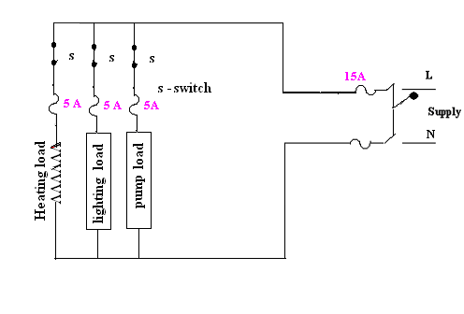

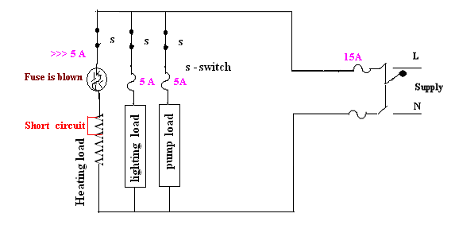

  - CHARACTERISTICS OF FUSE MATERIAL

The material used for fuse wires must have the following characteristics
    - Low melting point
    - Low ohmic losses
    - High conductivity
    - Lower rate of deterioration

  - Different types of fuses:

- Re-wirable or kit -kat fuses: These fuses are simple in construction, cheap and available up-to a current rating of 200A. They are erratic in operation and their performance deteriorates with time.
- Plug fuse: The fuse carrier is provided with a glass window for visual inspection of the fuse wire.
- Cartridge fuse: Fuse wire usually an alloy of lead is enclosed in a strong fiber casing. The fuse element is fastened to copper caps at the ends of the casing. They are available up-to a voltage rating of 25kV. They are used for protection in lighting installations and power lines.
- Miniature Cartridge fuses: These are the miniature version of the higher rating cartridge fuses, which are extensively used in automobiles, TV sets, and other electronic equipments.
- Transformer fuse blocks: These porcelain housed fuses are placed on secondary of the distribution transformers for protection against short circuits and overloads.
- Expulsion fuses: These consist of fuse wire placed in hollow tube of fiber lined with asbestos. These are suited only for out door use for example, protection of high voltage circuits.
- Semi-enclosed re-wirable fuses: These have limited use because of low breaking capacity.
- Time-delay fuse: These are specially designed to withstand a current overload for a limited time and find application in motor circuits.

  - HRC CARTRIDGE FUSE

The high rupturing capacity or (HRC) fuse consists of a heat resistant ceramic body. Then silver or bimetallic fuse element is welded to the end brass caps. The space surrounding the fuse element is filled with quartz powder. This filler material absorbs the arc energy and extinguishes it.
When the current exceeds the rated value the element melts and vaporizes. The vaporized silver fuses with the quartz and offers a high resistance and the arc is extinguished.

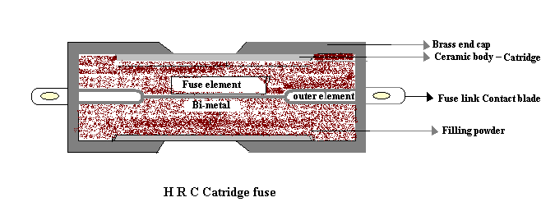

Advantages:
- Fast acting
- Highly reliable
- Relatively cheaper in comparison to other high current interrupting device

Disadvantages:
- Requires replacement
- The associated high temperature rise will affect the performance of other devices

- TERMS RELATED WITH FUSES

Rated current: It is the maximum current, which a fuse can carry without undue heating or melting. It depends on the following factors:
1. Permissible temperature rise of the contacts of the fuse holder and the
fuse material
2. Degree of deterioration due to oxidation

Fusing current: The minimum current at which the fuse melts is known as the fusing current. It depends on the material characteristics, length, diameter, cross-sectional area of the fuse element and the type of enclosure used.

Fusing Factor: It is the ratio of the minimum fusing current to the rated current. It is always greater than unity.

- FLUORESCENT LAMP

The fluorescent lamp is an energy saving device. It consumes less power for a given output lumens when compared to an incandescent lamp.
Construction:
It consists of a long glass tube filled with Argon an inert gas, at low pressure (2.5mm) and a small amount of mercury. The initial ionization voltage is reduced, as the ionization potential of argon is low. Two tungsten electrodes are placed at the ends, which are coated with rare earth oxides. These oxides having a low work function emit the ionizing electrons. A choke is connected in series with the electrode, which provides the voltage impulse of nearly 1000volts to start the discharge, and also limits the flow of current through the circuit. It also acts as ballast when the lamp is ON. The filament is connected to starter switch, a cathode glow lamp that has a bi-metallic strip as its electrodes. The capacitor C (0.02 μF) improves the power factor of the circuit while the capacitor C₁ (4 μF ) suppresses the radio interference.

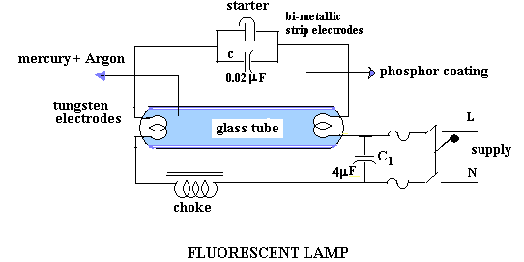

Working:
When the switch is closed the supply voltage comes across the starter electrodes initiating a glow discharge between them. This heats the bi-metallic strip electrodes, which expand and make contact completing the circuit. The resulting current flows through the tungsten electrodes and the electrons are emitted from the oxide coating (low work function), which initiate ionization of the gas molecules present in the glass tube. At this instant the bi-metallic strip electrodes cool and the starter opens. Thus there is a sudden interruption of the current, which induces a high voltage (`≅1000volts) in the choke.
This impulse strikes an arc between the electrodes lighting the lamp. The vaporized mercury gets ionized and emits radiations partly in the visible range and partly in ultraviolet range. The phosphor coating gives the required color and also absorbs the ultra violet light and re-radiates in the visible spectrum.

- SODIUM VAPOR LAMP

Sodium vapor lamps are mainly used for street lighting. They have low luminosity hence require glass tubes of large lengths, which makes them quiet bulky.

Construction:

The lamp consists of a U shaped inner glass tube filled with neon gas at a pressure of 10mm. It also contains a small quantity of sodium and argon gas. The initial ionization voltage is reduced, as the ionization potential of argon is low. Two oxide coated tungsten electrodes are sealed into the tube at the ends. This tube is enclosed in an outer double walled vacuum enclosure to maintain the required temperature.

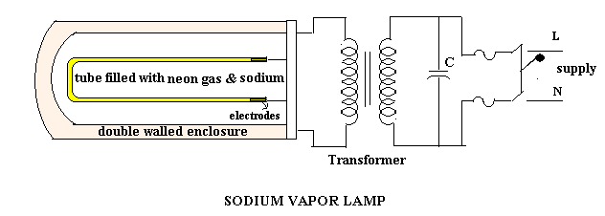

Working:

A voltage of the order of 380- 450 volts (depending on the wattage) is necessary to start the discharge, which is obtained from a high reactance transformer or an autotransformer. Initially the sodium vapor lamp operates as a low-pressure neon lamp emitting pink color. As the lamp gets heated and reaches a temperature of 200° C the sodium deposited on the sides of the tube walls vaporizes and radiates yellow light. It has a maximum efficiency at 220° C. Proper mounting of the lamp is to be ensured to prevent the sodium blackening the inner walls of the tube .A capacitor C is used to improve the power factor.

Questions

- Mention the different types of wiring. With relevant circuit diagrams and switching tables, explain the two – way and the three way control of lamps.
- Explain the different types of wiring used in practice
- Explain in brief the following:
- Fuses
- Specification of wires
- Earthing and its necessity
- Sketch any one type of earthing and indicate why such earthing of electrical equipments is necessary
- With a neat sketch explain any one method of earthing electrical appliance.
- With a neat circuit diagram, explain the two way control of a filament lamp.
- With a neat sketch explain the working of a sodium vapour lamp.
- Define domestic wiring. What important factors are to be considered in domestic wiring? Mention the difference types of wiring in practice.
- What do you understand by “Earthing”? With a neat diagram explain plate earthing.
- With a neat circuit diagram and a switching table, explain the two point control of a lamp.
- With a neat sketch explain the pipe earthing method.
- Explain the working principle of a fluorescent lamp when connected to an electrical supply source, with necessary auxiliary components and their functions

- THREE PHASE INDUCTION MOTOR

In this chapter you will be introduced to asynchronous motors or induction motors.

- Construction of squirrel cage and slip ring Induction motors
- Production of rotating flux
- Principle of operation
- Necessity of a starter for 3-phase induction motor
- Star –Delta starter
- Slip

By the end of the chapter you will be able to answer questions like:
- Why 3-phase induction motor cannot run with zero slip?
- Why 1-phase induction is motors not self starting?
- Why induction motors are the most preferred ac motors for many industrial applications?
- What do you understand by revolving flux?

  - INTRODUCTION

The asynchronous motors or the induction motors are most widely used ac motors in industry. They convert electrical energy in AC form into mechanical energy. They work on the principle of electromagnetic induction. They are simple and rugged in construction, quite economical with good operating characteristics and efficiency, requiring minimum maintenance, but have a low starting torque. They run at practically constant speed from no load to full load condition. The 3 - phase induction motors are self starting while the single phase motors are not self starting as they produce equal and opposite torques (zero resultant torque) making the rotor stationary. The speed of the squirrel cage induction motor cannot be varied easily.

- CLASSIFICATION -

They are basically classified into two types based on the rotor construction
- Squirrel cage motor
- Slip ring motor or phase wound motor

  - CONSTRUCTION

Three phase induction motor consists of two parts
(1) stator (2) rotor

- Stator

It is the stationary part of the motor supporting the entire motor assembly. This outer frame is made up of a single piece of cast iron in case of small machines. In case of larger machines they are fabricated in sections of steel and bolted together. The core is made of thin laminations of silicon steel and flash enameled to reduce eddy current and hysteresis losses. Slots are evenly spaced on the inner periphery of the laminations. Conductors insulated from each other are placed in these slots and are connected to form a balanced 3 - phase star or delta connected stator circuit. Depending on the desired speed the stator winding is wound for the required number of poles. Greater the speed lesser is the number of poles.

- Rotor

Squirrel cage rotors are widely used because of their ruggedness. The rotor consists of hollow laminated core with parallel slots provided on the outer periphery. The rotor conductors are solid bars of copper, aluminum or their alloys. The bars are inserted from the ends into the semi-enclosed slots and are brazed to the thick short circuited end rings. This sort of construction resembles a squirrel cage hence the name “squirrel cage induction motor”. The rotor conductors being permanently short circuited prevent the addition of any external resistance to the rotor circuit to improve the inherent low starting torque. The rotor bars are not placed parallel to each other but are slightly skewed which reduces the magnetic hum and prevents cogging of the rotor and the stator teeth.

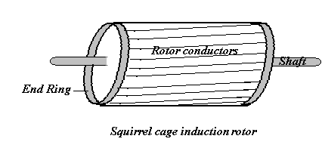

The rotor in case of a phase wound/ slip ring motor has a 3-phase double layer distributed winding made up of coils, similar to that of an alternator. The rotor winding is usually star connected and is wound to the number of stator poles. The terminals are brought out and connected to three slip rings mounted on the rotor shaft with the brushes resting on the slip rings. The brushes are externally connected to the star connected rheostat in case a higher starting torque and modification in the speed torque characteristics are required. Under normal running conditions all the slip rings are automatically short circuited by a metal collar provided on the shaft and the condition is similar to that of a cage rotor. Provision is made to lift the brushes to reduce the frictional losses. The slip ring and the enclosures are made of phosphor bronze.

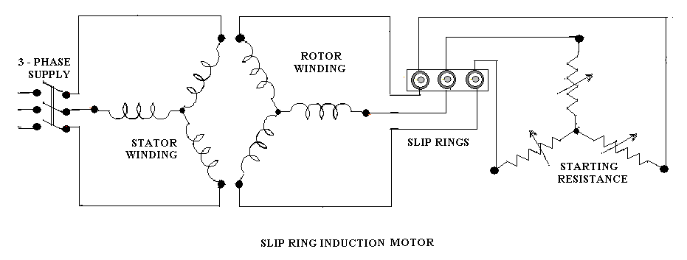

In both the type of motors the shaft and bearings (ball and roller) are designed for trouble free operation. Fans are provided on the shaft for effective circulation of air. The insulated (mica and varnish) stator and rotor windings are rigidly braced to withstand the short circuit forces and heavy centrifugal forces respectively. Care is taken to maintain a uniform air gap between the stator and the rotor.

- Comparison of the squirrel cage and slip ring rotors

The cage rotor has the following advantages:

- Rugged in construction and economical.
- Has a slightly higher efficiency and better power factor than slip ring motor.
- The absence of slip rings and brushes eliminate the risk of sparking which helps in a totally enclosed fan cooled (TEFC) construction.

The advantages of the slip ring rotor are:
- The starting torque is much higher and the starting current much lower when compared to a cage motor with the inclusion of external resistance.
- The speed can be varied by means of solid state switching

- WORKING OF THE INDUCTION MOTOR

- Production of a rotating magnetic field

Consider a 3- phase induction motor whose stator windings mutually displaced from each other by 120° are connected in delta and energized by a 3- phase supply.
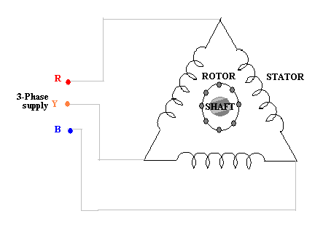

. The currents flowing in each phase will set up a flux in the respective phases as shown.
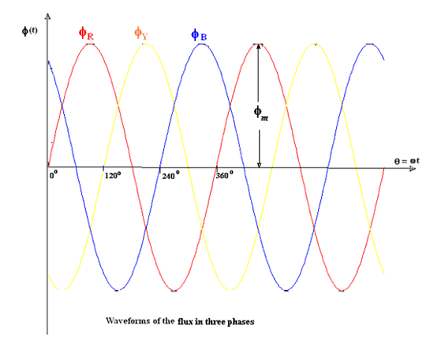

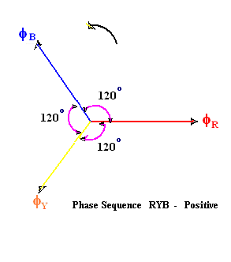
The corresponding phase fluxes can be represented by the following equations

$$\begin{aligned}Φ_{R}=Φ_{m}\text{sin}ωt=Φ_{m}\text{sin}θ \\ Φ_{Y}=Φ_{m}\text{sin}\left(ωt−\text{120}°\right) \\ Φ_{Y}=Φ_{m}\text{sin}\left(θ−\text{120}°\right)\end{aligned}$$
The resultant flux at any instant is given by the vector sum of the flux in each of the phases.

(i) When $θ=0^{∘}$, from the flux waveform diagram ,we have
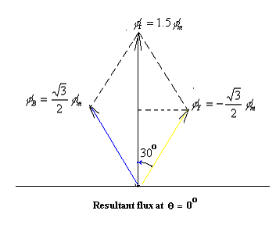
$\begin{aligned}φ_{R}=0 \\ φ_{Y}=φ_{\text{km}}\text{sin}(−{\text{120}}^{∘})=−\frac{\sqrt{3}}{2}φ_{m} \\ φ_{B}=φ_{m}\text{sin}(−{\text{240}}^{∘})=\frac{\sqrt{3}}{2}φ_{m} \\ \\ \text{The}\text{ resultant flux }φ_{r}\text{ is given by,} \\ \\ φ_{r}=2∗\frac{\sqrt{3}}{2}φ_{m}\text{cos}({\text{30}}^{∘})=1\text{.}\text{.}5φ_{m}\end{aligned}$

$$φ_{B}=\frac{\sqrt{3}}{2}φ_{m}$$

$$φ_{Y}=−\frac{\sqrt{3}}{2}φ_{m}$$

$$φ_{r}=1\text{.}5φ_{m}$$

(ii)$\text{When} θ={\text{60}}^{∘}$

$$\begin{aligned}φ_{R}=\frac{\sqrt{3}}{2}φ_{m} \\ φ_{Y}=−\frac{\sqrt{3}}{2}φ_{m} \\ φ_{B}=0\end{aligned}$$
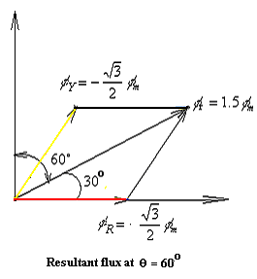

(iii) $\text{When} θ=\text{12}0^{∘}$
$$φ_{R}=\frac{\sqrt{3}}{2}φ_{m}$$

$$φ_{Y}=0$$

$$φ_{B}=−\frac{\sqrt{3}}{2}φ_{m}$$

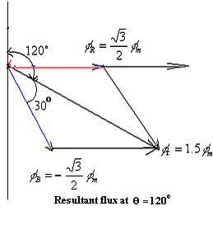

(iv) $\text{When} θ={\text{180}}^{∘}$
$$\begin{aligned}φ_{R}=0; \\ φ_{Y}=\frac{\sqrt{3}}{2}φ_{m} \\ φ_{B}=−\frac{\sqrt{3}}{2}φ\end{aligned}$$
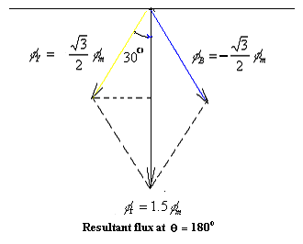
From the above discussion it is very clear that when the stator of a 3-phase induction motor is energized, a magnetic field of constant magnitude (1.5 φ_{m}) rotating at synchronous speed
(N_{s}) with respect to stator winding is produced.

(b) Rotation of the rotor
Consider a 3- phase stator winding energized from a 3 phase supply. As explained earlier a rotating magnetic field is produced running at a synchronous speed N_{S}

120 f
N_{S} = ---------
P

Where f = supply frequency
P = Number of stator poles

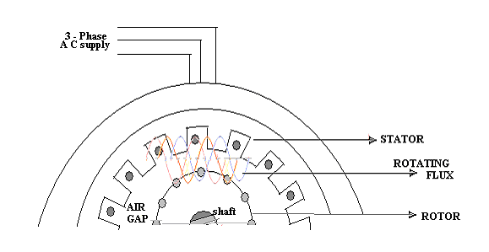

 ANIMATION INSTRUCTION

As soon as the supply is switched on you can show
The three phase flux revolving in the air gap
The flow of current through the rotor conductors
The rotation of the rotor in the direction of the 3- phase flux but with a difference in speed (trailing behind) between them indicating the slip speed
When their speeds become equal the rotor should tend to stop rotating indicating zero slip

Consider a portion of 3- phase induction motor as shown in the above figure which is representative in nature. The rotating field crosses the air gap and cuts the initially stationary rotor conductors. Due to the relative speed between the rotating magnetic field and the initially stationary rotor,(change of flux linking with the conductor) an e.m.f. is induced in the rotor conductors, in accordance with the Faraday’s laws of electromagnetic induction. Current flows in the rotor conductors as the rotor circuit is short circuited. Now the situation is similar to that of a current carrying conductor placed in a magnetic field. Hence, the rotor conductors experience a mechanical force which eventually leads to production of torque. This torque tends to move the rotor in the same direction as that of the rotating magnetic field.

- CONCEPT OF SLIP (S)

According to Lenz’s law, the direction of rotor current will be such that they tend to oppose the cause producing it. The cause producing the rotor current is the relative speed between the rotating field and the stationary rotor. Hence, to reduce this relative speed, the rotor starts running in the same direction as that of stator field and tries to catch it. In practice the rotor can never reach the speed of the rotating magnetic field produced by the stator. This is because if rotor speed equals the synchronous speed, then there is no relative speed between the rotating magnetic field and the rotor. This makes the rotor current zero and hence no torque is produced and the rotor will tend to remain stationary. In practice, windage and friction losses cause the rotor to slow down. Hence, the rotor speed (N) is always less than the stator field speed (N_{S}). Thus the induction motor cannot run with ZERO SLIP. The frequency of the rotor current
f_{r} = sf. The difference between the synchronous speed (N_{S}) of the rotating stator field and the actual rotor speed (N) is called the slip speed.

Slip speed = N_{S –} N depends upon the load on the motor

N_{S -} N
% Slip (s) = ---------- * 100
N_{S}

Note: In an induction motor the slip value ranges from 2% to 4%

- APPLICATIONS OF INDUCTION MOTORS

Squirrel cage induction motor

Squirrel cage induction motors are simple and rugged in construction, are relatively cheap and require little maintenance. Hence, squirrel cage induction motors are preferred in most of the industrial applications such as in
  - Lathes
  - Drilling machines
  - Agricultural and industrial pumps
  - Industrial drives.

Slip ring induction motors

Slip ring induction motors when compared to squirrel cage motors have high starting torque, smooth acceleration under heavy loads, adjustable speed and good running characteristics.

They are used in

- Lifts
- Cranes
- Conveyors , etc.,

  - Necessity of starters for 3 phase induction motor

When a 3- phase motor of higher rating is switched on directly from the mains it draws a starting current of about 4 -7 times the full load (depending upon on the design) current. This will cause a drop in the voltage affecting the performance of other loads connected to the mains. Hence starters are used to limit the initial current drawn by the 3 phase induction motors.
The starting current is limited by applying reduced voltage in case of squirrel cage type induction motor and by increasing the impedance of the motor circuit in case of slip ring type induction motor. This can be achieved by the following methods.

1. Star –delta starter
2. Auto transformer starter
3. Soft starter

- Star delta starter

The star delta starter is used for squirrel cage induction motor whose stator winding is delta connected during normal running conditions. The two ends of each phase of the stator winding are drawn out and connected to the starter terminals as shown in the following figure.

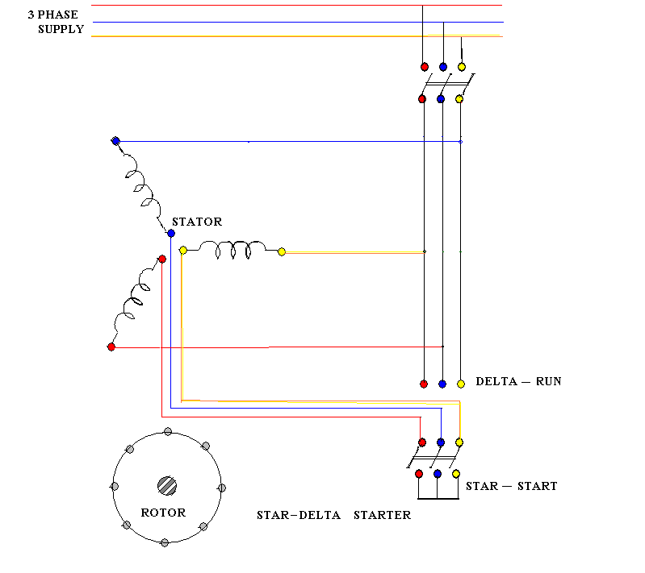

ANIMATION INSTRUCTION

When the switch is closed on the star-start side
    - The winding is to be shown connected in star
    - The current I = 1/3 * (I _{direct switching})
(3) Reduction in voltage by1/√3
V = V _{supply}*1/√3
When the switch is closed on to delta –run side

- the winding to be shown connected in delta
- application of normal voltage V _{supply}
- normal current I

During staring the starter switch is thrown on to the STAR - START. In this position the stator winding is connected in star fashion and the voltage per phase is 1/√3 of the supply voltage. This will limit the current at starting to 1/3 of the value drawn during direct switching. When the motor accelerates the starter switch is thrown on to the DELTA - RUN side. In this position the stator winding gets connected in the Δ fashion and the motor draws the normal rated current.

- WORKED EXAMPLES

1. A 12 pole, 3 phase alternator is coupled to an engine running at 500 rpm. It supplies an Induction Motor which ahs a full load speed of 1440 rpm. Find the percentage slop and the number of poles of the motor.

Solution: N_{A} = synchronous speed of the alternator

PN_{A} 12 X 500
F =------- = --------------- = 50 Hz (from alternator data)
120 120

When the supply frequency is 50 Hz, the synchronous speed can be 750 rpm, 1500 rpm, 3000rpm etc., since the actual speed is 1440 rpm and the slip is always less than 5% the synchronous speed of the Induction motor is 1500 rpm.

N_{S} – N 1500 - 1440
s = --------- = ----------------- = 0.04 OR 4%
N_{S} 1500

120f 120 x 50
N_{S} = ------------ = -------------- = 1500
P P
∴ P = 4

2. A 6 pole induction motor is supplied by a 10 pole alternator, which is driven at 600 rpm. If the induction motor is running at 970 rpm, determine its percentage slip.
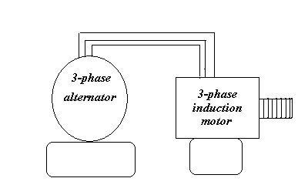
P N_{A} 10 X 600
From alternator date: f =------- = --------------- = 50 Hz
120 120
Synchronous speed of the induction motor
From I.M. data: $\begin{aligned}N_{S}=\frac{\text{120}f}{P}=\frac{\text{120}×\text{50}}{6}=\text{1000}\text{rpm} \\ \text{\%}\text{slip}=\frac{N_{S}−N}{N_{S}}×\text{100}=\frac{\text{1000}−\text{970}}{\text{1000}}=3\text{\%}\end{aligned}$

3. A 12 pole, 3 phase alternator is driven by a 440V, 3 phase, 6 pole Induction Motor running at a slip of 3%. Find frequency of the EMF generated by the alternator

For induction motor: $N_{S}=\frac{\text{120}f}{P}=\frac{\text{120}×\text{50}}{6}=\text{1000}\text{rpm}$

$$N=\left(1−s\right)N_{S}=\left(1−0\text{.}\text{03}\right)\text{1000}=\text{970}\text{rpm}$$

As the alternator is driven by the Induction motor, the alternator runs at 970 r.p.m.

For alternator: $f=\frac{\text{PN}}{\text{120}}=\frac{\text{12}×\text{970}}{\text{120}}=\text{97}\text{Hz}$

4. A three phase 4 pole, 440 V, 50Hz induction motor runs with a slip of 4%. Find the rotor speed and frequency of the rotor current.

Solution: $\begin{aligned}N_{S}=\frac{\text{120}f}{P}=\frac{\text{120}×\text{50}}{4}=\text{1500}\text{rpm} \\ S=\frac{N_{S}−N}{N_{S}}i\text{.}e\text{.}0\text{.}\text{04}=\frac{\text{1500}−N}{\text{1500}},∴N=\text{1440}\text{rpm} \\ f_{r}=\text{sf}=0\text{.}\text{04}×\text{50}=2\text{Hz}\end{aligned}$

5. A 3 phase, 50Hz 6 pole induction motor has a full load percentage slip of 3%.
Find(i) Synchronous speed and (ii) Actual Speed

Solution: $\begin{aligned}N_{S}=\frac{\text{120}f}{P}=\frac{\text{120}×\text{50}}{6}=\text{1000}\text{rpm} \\ S=\frac{N_{S}−N}{N_{S}}i\text{.}e\text{.}0\text{.}\text{03}=\frac{\text{100}−N}{\text{1000}}∴N=\text{970}\text{rpm}\end{aligned}$

6. A 3 phase induction motor has 6 poles and runs at 960 RPM on full load. It is supplied from an alternator having 4 poles and running at 1500 RPM. Calculate the full load slip and the frequency of the rotor currents of the induction motor.

Solution:
$$\begin{aligned}f=\frac{\text{PN}}{\text{120}}=\frac{4×\text{1500}}{\text{120}}=\text{50}\text{Hz}(\text{from}\text{alternator}\text{data}) \\ \text{forInduction}\text{motor} \\ N_{S}=\frac{\text{120}f}{P}=\frac{\text{120}×\text{50}}{6}=\text{1000}\text{rpm} \\ S=\frac{N_{S}−N}{N_{S}}=\frac{\text{1000}−\text{960}}{\text{1000}}=0\text{.}\text{04}\text{ or 4\%} \\ fr=\text{sf}=0\text{.}\text{04}×\text{50}=2\text{Hz}\end{aligned}$$

7. The frequency of the e.m.f in the stator of a 4-pole induction motor is 50 Hz and that of the rotor is$\begin{aligned}1\frac{1}{2}\text{Hz} \\ \end{aligned}$. What is the slip and at what speed is the motor running?
Solution:
Given P = 4
f = 50Hz
$\begin{aligned}f_{r}=1\text{.}5\text{Hz} \\ \end{aligned}$
- To calculate slip (s)

We have $\begin{aligned}f_{r}=\text{sf} \\ 1\text{.}5=S×\text{50} \\ s=\frac{1\text{.}5}{\text{50}} \\ s=0\text{.}\text{03} \\ s=3\text{\%}\end{aligned}$

ii) To calculate the speed of the motor (N)

We have
$\begin{aligned}N_{s}=\frac{\text{120}f}{P} \\ N_{s}=\frac{\text{120}×\text{50}}{4}=\text{1500}\text{rpm}\end{aligned}$

We also have
$\begin{aligned}N=N_{s}\left(1−s\right) \\ N=\text{1500}\left(1−0\text{.}\text{03}\right) \\ N=\text{1455}\text{rpm} \\ \end{aligned}$
8. A 3-phase, 60Hz induction motor has a slip of 3% at full load. Find the synchronous speed, the full- load speed and the frequency of rotor current at full load.

Solution
Given P = 6
f = 60Hz
s= 3% = 0.03
- To find the synchronous speed (N_{s})
We have
$\begin{aligned}N_{s}=\frac{\text{120}f}{P}=\frac{\text{120}×\text{60}}{6} \\ N_{s}=\text{1200}\text{rpm}\end{aligned}$

- To calculate the full load speed (N)
We have
$\begin{aligned}N=N_{s}\left(1−s\right)=\text{1200}(1−0\text{.}\text{03}) \\ N=\text{1164}\text{rpm}\end{aligned}$

- To calculate the frequency of the rotor current ( f_{r})
We have
$\begin{aligned}f_{r}=\text{sf}=0\text{.}\text{03}×\text{60} \\ f_{r}=1\text{.}8\text{Hz}\end{aligned}$

9. A 6-pole alternator running at 600 rpm. supplies a 3-phase, 4-pole induction motor. If the induction motor induced e.m.f makes 2 alternations per second, find the speed of the motor.

Solution

- Alternator
P = 6
N_{s} = 600
We have the frequency of induced e.m.f of an alternator given by
$f=\frac{{\text{PN}}_{s}}{\text{120}}=\frac{6×\text{600}}{\text{120}}=\text{30}\text{Hz}$
Hence, induction motor receives the supply at 30Hz frequency
- Induction motor
It is given that the rotor induced e.m.f makes two alternations per second i.e. 1.0 cycle per second
We have $\begin{aligned}∴f_{r}=1\text{.}0\text{Hz} \\ f_{r}=\text{sf} \\ s=\frac{f_{r}}{f}=\frac{1\text{.}0}{\text{30}} \\ s=0\text{.}\text{033}\end{aligned}$

The speed of the rotating magnetic field is given by
$N_{s}=\frac{\text{120}f}{P_{m}}$ Where P_{m} = Number of poles of induction motor
$N_{s}=\frac{\text{120}×\text{30}}{4}=\text{900}\text{rpm}$
The speed of the induction motor (N) is given by
$\begin{aligned}N=N\left(1−s\right)=\text{900}\left(1−0\text{.}\text{033}\right) \\ N=\text{870}\text{rpm}\end{aligned}$

10. A 10-pole induction motor is supplied by a 6-pole alternator, which is driven at 1200rpm. If the motor runs with a slip of 3, what is the speed of the induction motor?

Solution
- Alternator
P = 6 pole
N_{s} = 1200rpm
Therefore, the frequency of the e.m.f generated is given by
$\begin{aligned}f=\frac{{\text{PN}}_{s}}{\text{120}}=\frac{6×\text{1200}}{\text{120}} \\ f=\text{60}\text{Hz}\end{aligned}$
Hence, the induction motor is supplied at 60Hz frequency.

- Induction motor
Supply frequency = f = 60Hz
Slip = S = 3%
Stator poles = P_{m} =10
Speed of the rotating magnetic field,
$\begin{aligned}N_{s}=\frac{\text{120}f}{P_{m}}=\frac{\text{120}×\text{60}}{\text{10}} \\ N_{s}=\text{720}\text{rpm} \\ \end{aligned}$
Speed of the motor
$\begin{aligned}N=N_{s}\left(1−S\right)=\text{720}\left(1−0\text{.}\text{03}\right) \\ N=\text{698}\text{.}4\text{rpm}\end{aligned}$

11. A 3-phase induction motor has 6-poles and runs at 960r.p.m. on full load. It is supplied from an alternator having 4-poles and running at 1500 r.p.m. calculate the full load slip of the motor.

Solution
- Alternator
P = 4 poles
N_{s} = 1500 rpm
The frequency generated e.m.f is given by
$\begin{aligned}f=\frac{{\text{PN}}_{s}}{\text{120}}=\frac{4×\text{1500}}{\text{120}} \\ f=\text{50}\text{Hz}\end{aligned}$

Hence, the induction motor is supplied at 50 Hz
- Induction motor
$\begin{aligned}P_{m}=6\text{poles} \\ f=\text{50}\text{Hz} \\ N=\text{960}\text{rpm}\end{aligned}$
The speed of the rotating magnetic field is given by
$\begin{aligned}N_{s}=\frac{\text{120}f}{P_{m}}=\frac{\text{120}×\text{50}}{6} \\ N_{s}=\text{1000}\text{rpm}\end{aligned}$
We have slip of an induction motor given by
$\begin{aligned}S=\frac{N_{s}−N}{N_{s}}=\frac{\text{1000}−\text{960}}{\text{1000}}=0\text{.}\text{04} \\ S=4\text{\%}\end{aligned}$

12. A 4-pole, 30hp, 3-phase 400 volts, 50Hz induction motor operates at an efficiency of 0.85 with a power factor of 0.75(lag). Calculate the current drawn by the induction motor from the mains

Solution

Given P = 4
V = 400
ή = 0.85
cos φ = 0.75
Output= 30 hp
= 22.06538 Kw ( 1metric hp=735.5 watts)
We have,
$\begin{aligned}η=\frac{\text{Output}}{\text{Input}} \\ \text{Input}=\frac{\text{Output}}{η}=\frac{\text{22}\text{.}\text{065}}{0\text{.}\text{85}} \\ \text{Input}=\text{25}\text{.}\text{96}\text{KW}\end{aligned}$
But, for a 3-phase induction motor circuit, the power input is also given by the expression
$\begin{aligned}P=\sqrt{3}V_{L}I_{L}\text{cos}Φ \\ I_{L}=\frac{P}{\sqrt{3}V_{L}\text{cos}Φ}=\frac{\text{25}\text{.}\text{96}×\text{1000}}{\sqrt{3}×\text{400}×0\text{.}\text{75}} \\ I_{L}=\text{49}\text{.}\text{94}\text{Amperes}\end{aligned}$

13. A 5 hp, 400V, 50Hz, 6-pole, 3-phase induction motor operating on full load draws a line current of 7 amperes at 0.866 power factor with 2%slip. Find the rotor speed.

Solution.

Given P = 6
s = 2%
= 0.02
cos φ = 0.866
f = 50 Hz
$\begin{aligned}\text{Output}=5\text{hp}=5×\text{735}\text{.}5\text{watts} \\ \text{Output}=3\text{.}\text{677}\text{KW} \\ I_{L}=7\text{amperes}\end{aligned}$

To find the rotor speed:
Speed of the rotor magnetic field is given by
$\begin{aligned}N_{s}=\frac{\text{120}f}{P}=\frac{\text{120}×\text{50}}{6} \\ N=\text{1000}\text{rpm}\end{aligned}$
Speed of the rotor = N =N_{s} (1-s)
= 1000(1-0.02)
N = 980rpm

14. A 3-phase, 6-pole, 50 Hz induction motor has a slip of 1% at no-load and 3%at full-load. Find:
- Synchronous speed,
- No-load speed
- Full-load speed,
- Frequency of rotor current at standstill, and
- Frequency of rotor current at full-load

Solution. Number of poles, p = 6
No- load slip, s₀ = 1%
Full-load slip, s_{f} = 3%

- Synchronous speed,
$N_{s}=\frac{\text{120}f}{p}=\frac{\text{120}×\text{50}}{\text{60}}=\text{1000}r\text{.}p\text{.}m\text{.}(\text{Ans})$
- No-load speed N_{0 ,}

We know that
$\begin{aligned}s=\frac{N_{s}−N}{N_{s}}\text{orN}=N_{s}\left(1−s\right) \\ N_{0}=N_{s}\left[1−s_{0}\right]=\text{100}\left[1−\frac{1}{\text{100}}\right]=\text{990}r\text{.}p\text{.}m\text{.}(\text{Ans})\end{aligned}$
- Full – load speed
$N_{f}=N_{s}\left[1−s_{f}\right]=\text{1000}\left[1−\frac{3}{\text{100}}\right]=\text{970}r\text{.}p\text{.}m\text{.}(\text{Ans})$
4. Frequency of rotor current at standstill, f_{r}
At standstill,
$\begin{aligned}s=1 \\ f_{r}=\text{sf}=1×\text{50}=\text{50}\text{Hz}\text{.}(\text{Ans})\end{aligned}$

5. Frequency of rotor current at full – load, f_{r}=?
$f_{r}=s×f=\frac{3}{\text{100}}×\text{50}=1\text{.}5\text{Hz}\text{.}(\text{Ans})$

15. A 3-phase, 12-pole alternator is coupled to an engine running at 500 rpm. The alternator supplies an induction motor which has a full-load speed of 1455rpm. Find the slip and number of poles of the motor.

Solution.
Number of poles of the alternator, p_{a} =12
Speed of the engine, N_{e} = 500rpm
Full-load speed of the induction motor, N_{m} = 1455rpm
Slip, s =?
Number of poles of the induction motor, P_{m} =?
Supply frequency,
$f=\frac{N_{a}p_{a}}{\text{120}}=\frac{\text{500}×\text{12}}{\text{120}}=\text{50}\text{Hz}$
When the supply frequency is 50Hz, the synchronous speed can be 3000, 1500, 1000, 750 rpm etc. since the full-load speed is 1455rpm and the full-load slip is always less than 4%, the synchronous speed is1500rpm.
Slip,
$s=\frac{N_{s}−N}{N_{s}}=\frac{\text{1500}−\text{1455}}{\text{1500}}=0\text{.}\text{03}\text{or}3\text{\%}(\text{Ans})$

Also,
$\begin{aligned}N_{s}=\frac{\text{120}f}{P_{m}} \\ P_{m}=\frac{\text{120}f}{N_{s}}=\frac{\text{120}×\text{50}}{\text{1500}}=4\text{poles}\end{aligned}$
Hence, number of motor poles = 4. (Ans)

16. A 4- pole, 50 Hz induction motor at no-load (N_{NL}) has a slip of 2%. When operated at full load the slip increases to 3%. Find the change in speed of the motor from no-load to full load.

$\begin{aligned}N=\frac{\text{120}f}{P} \\ =\frac{\text{120 x 50}}{4}=\text{1500}\text{rpm} \\ \text{no}−\text{load}\text{ speed }N_{\text{NL}}=N_{S}(1−S_{\text{NL}}) \\ =\text{1500}(1−0\text{.}\text{02})=\text{1470}\text{rpm} \\ \text{full}\text{load}\text{speed}N=N_{S}(1−S_{\text{FL}}) \\ =\text{1500}(1−0\text{.}\text{03}) \\ =\text{1455}\text{rpm} \\ \text{change in speed from no-load to full load} \\ {\text{ N}}_{\text{NL }}−N_{\text{FL}}=\text{1470}−\text{1455}=\text{15}\text{rpm}\end{aligned}$

- ANSWER THE FOLLOWING QUESTIONS

(1)What do you mean by rotating magnetic field and explain the production of torque in a three phase induction motor?
(2) A three phase, 50 Hz 6 pole induction motor has a full load percentage slip o 3%.Find the synchronous speed and the actual speed.
(3) Explain how torque is produced in a 3-phase induction motor?
(4) Why a 3-phase induction motor cannot run with zero slip?
(5) What do you understand by slip?
(6)Why is a single phase induction motor not self starting?
(7)Why starters are necessary for starting a 3-phase induction motor?
(8)Explain with a neat diagram the working of a STAR-DELTA starter?
(9)Bring out the differences between a squirrel cage and a slip ring induction motor.
(10)Why is squirrel cage induction motor widely used for industrial applications?
(11) Mention the applications of squirrel cage and slip ring induction motors.

Notes by V.Muralidhar BIT, Bangalore

D.C. MACHINES.
Working principle of D.C.Machine as generator and motor, constructional features, EMF equation of generator and simple problems, back emf and torque equation of DC motors, simple problems, types of DC motors, characteristics and applications, necessity of starter, 3-point starter.
______________________________________________________________________
A machine which works on direct current is defined as a D.C.Machine.

D.C.Machines are of two types. (i) D.C.Generator and (ii) D.C.Motor.

Sl.No. | D.C. Generator | D.C.Motor
1 | Definition:  A generator is a rotating  machine which converts  mechanical energy into  electrical energy | Definition:  A motor is a machine which converts electrical energy into mechanical energy
2 | Principle:  Whenever a coil is rotated in a magnetic field an e.m.f. will be induced in this coil  and is given by  e=BlvSinθ volts/coil side  where, B=The flux density in Tesla, l=the active length of the coil side in meters, v=the velocity with which the coil is moved in meters/sec and θ is the angle between the direction of the flux and the direction of rotation of the coil side. | Principle:  Whenever a current coil is placed under a magnetic field the coil experiences a mechanical force, and is given by F= BIlSinθ Newtons/coil side.  Where, I is the current through the coil in ampere.
3 | The direction of the emf induced is fixed by applying the Fleming’s right hand rule | The direction of the force acting is fixed by applying the Fleming’s left hand rule.

CONSTRUCTION OF A D.C.MACHINE.

Salient parts of a D.C.machine are:
- Field system (poles)
- Coil arrangement (armature)
- Commutator
- Brushes
- Yoke

Fig shows the details of a four pole D.C. machine with both shunt and series field windings.
Field system: This is made of electromagnets, wherein a iron laminated core is wound with well insulated enameled copper wire. The core is laminated to minimize the eddy current loss. Each lamination is dipped in varnish and dried. A pole shoe is attached to the pole face to direct the flux to concentrate radially on to the armature thereby reducing the leakage and fringing flux. Poles are fixed to the yoke by means of bolts.
Armature: This is the rotating part of the machine made of laminated iron core cylindrical in structure with slots on its periphery. Insulated copper coils are laid in these slots, and these coils are connected for lap or wave connection. The core laminations are firmly mounted on a shaft fitted with smooth bearings on either side for smooth rotation.

Comparison of lap and wave windings:
LAP | WAVE
Number of armature parallel paths is equal to the number of poles. | Number of parallel paths is always equal to two.
Preferred when large current at lesser voltage is the requirement. | Preferred when large voltage with lesser current is the requirement.

Commutator: As the induced e.m.f. in the armature is alternating commutator converts alternating e.m.f. into unidirectional e.m.f.
This is cylindrical in structure made of copper segments with mica insulation between them and is firmly fixed on to the shaft carrying the armature and the armature coil free ends are brazed to the commutator segments.
Brushes: These are current collecting devices placed on the body of the commutator with a holder. Brushes are made of carbon, copper or graphite.
Yoke: This is the outer most part of the machine made of cast steel which is the mechanical enclosure for the machine to protect it from dust and moisture and also provides the return path for the magnetic flux and carries half the flux per pole.

E.M.F. Equation:
Let the D.C. machine has P number of poles, Z number of armature conductors arranged in A number of parallel paths. Let Ф be the flux per pole and N is the speed of rotation in revolutions per minute.
Consider one North Pole of the machine under which a group of armature conductors all being connected in series. Let x be the spacing between any two neighboring conductors ant t be the time taken to move through this distance of x.
The total flux per pole Ф is made of several lines and one line of flux is cut by one conductor when it moves through a distance of x in t seconds.
Therefore the induced emf in the 1st conductor when cut by the flux of Ф₁
is
e₁ ₌ Ф₁/t volts
Similarly in the 2nd conductor e₂ = Ф2/t volts, and so on.

Therefore the total emf induced in all the conductors under one pole is the sum of all these emf’s.

E= e₁ + e₂ + e₃ + e₄ + ……..
E= Ф₁/t + Ф2/t + Ф3/t + Ф4/t + ……..
E= Ф/t volts/pole.
For all the P number of poles E= PФ/t volts
The speed is defined as N revolutions per minute,
N revolutions in one minute or 60 seconds.
1 revolutions will be in time of 60/N seconds, and as one revolution corresponds to all the Z number of conductors the time t for a travel of distance x can be written as t= 60/NZ seconds.
Therefore the induced EMF E= PФ/t = PФ/60/(NZ)=PZNФ/60.
As the Z number of conductors are arranged in A number of parallel paths,
The induced e.m.f per parallel path is

E= PZNФ/60A volts.

As P, Z, A are fixed the induced e.m.f is mainly dependent on the flux and the speed, and hence we write that the induced e.m.f E is proportional to the product of the speed N and the flux Ф.

Types of D.C. Generators.

D.C. Generators are classified on the basis of the method of exciting the field coils as (i) Separately excited generators and
(ii) Self excited generators.
In separately excited type the field coils are excited from an independent D.C. source.
In self excited type excitation of the field coils are done by feeding back a part of the output of the generator.
Self excitation can be done in three ways:
- By connecting the field coils across the armature- Shunt excitation ( Fig 1.)
- By connecting the field coils in series with the armature- Series. (Fig 2) excitation.
- By using both the shunt and series field coils together- Compound excitation.
In compound excitation the fluxes due to the shunt field and the series field may support each other or oppose each other and accordingly they are called Cumulatively compounded or Differentially compounded generators. (Figs. 3 and 4.)

There are two more ways of connecting the shunt and series field coils with the armature: (i) Long shunt connection:- Here the armature and the series field coils are connected in series and the shunt field circuit is connected in parallel with this combination. (Fig. 5.)
(ii) Short shunt connection: - Here the armature and the shunt field circuits are connected in parallel and the series field coils are connected in series with this combination.( Fig. 6)

Questions and Problems on D.C. Generators:

- Draw the cross sectional views of a typical 4 pole D.C. machine and explain the function of each part.
- With usual notations derive expression for the induced emf of a D.C. machine.
- A 4 pole generator with wave wound armature has 51 slots, each having 24 conductors. The flux per pole is 0.01 wb. At what speed must the armature be rotated to give an induced emf of 220 volt. What will be the voltage developed if the winding is lap and the armature rotates at the same speed.
- Find the useful flux per pole of a 250 V, 6pole shunt generator having two circuit connected armature winding with 220 conductors. At normal temperature the overall armature resistance including brushes is 0.2 ohm. The armature current is 13 A and the speed is 910 rpm.
- A 4 pole, 100V, shunt generator with lap connected armature winding having a field and armature resistances of 50 and 0.1 ohm respectively supplies sixty, 100V, 40 watt lamps. Calculate the total armature current, current per parallel path and the generated emf.
- A long shunt cumulatively compounded D.C. generator supplies 7.5 KW
power at 250V. The shunt field, series field and armature resistances are respectively 125 ohm, 0.3 ohm and 0,5 ohm. Calculate the induced emf.
- In a 110V compound generator the resistances of the armature, shunt
and series field coils are 0.06, 25 and 0.04 ohms respectively. The load
consists of 200 lamps each rated at 55 Watt, 110 Volt. Find the
generated emf when connected for (i) Long shunt and (ii) Short shunt.

D.C. MOTOR.

Principle: Whenever a current coil is placed in a magnetic field the coil experiences a
mechanical force, and is given by

F=BIlSinθ newtons. Where B is the flux density in Tesla
I is the current through the coil
l is the active length of the coil side
θ is the angle between the movement of the
coil and the direction of the flux
The direction of the force acting can be decided by applying Fleming’s left hand rule.

The construction of a D.C.Motor is same as the construction of a D.C.generator.

Types of D.C.Motors:
Depending on the interconnection between the armature and the field circuit D.C.Motors are classified as (i) Shunt Motor, (ii) Series Motor and (iii) Compound motors just like D.C.Generators.

Back EMF: Whenever a current coil is placed under a magnetic field the coil experiences a mechanical force due to which the coil starts rotating. This rotating coil again cuts the magnetic lines of force resulting an EMF induced in it whose direction is to oppose the applied EMF (as per Fleming’s right hand rule), and hence the name BACK EMF or Counter Emf.

Significance of Back EMF: Back EMF is a must in a motor which helps to regulate the armature current and also the real cause for the production of torque.

Expression for the back Emf is given by E=V-IaRa,
Where E is the back emf, V is the applied emf, Ia is the armature current and Ra is the armature circuit resistance. And also E= PZNФ/60A volts, from the machine parameters.

Production of torque in a D.C. Motor.

The production of torque in a d.c. motor can be well explained with the help of the following figures.

Fig (a) represents the magnetic field distribution between a bipolar magnet from North pole to South pole.
Fig(b) shows the field set up around a current carrying coil
In fig © the current carrying coil is brought under the influence of bipolar magnetic field.
The resultant field around the coil due to the inter action of the main field and the coil field is seen in fig (d) where in the flux is strengthened in the left part of the upper coil side and weakened in the right part of the upper coil side and vice-versa in the lower coil side. The resultant flux which strengthened at one point exerts a force on the conductor as per Fleming’s left hand rule and thereby the coil side experiences a mechanical force.

In the construction it is seen that several coils sides are on the armature and the tangential force acting on each of these coil sides add each other and resulting in a unidirectional movement which makes the armature to rotate at a uniform speed thereby torque is produced.

TORQUE EQUATION:

Let P be the total number of poles, Z be the total number of armature conductors arranged in A number of parallel paths. Let Ф be the flux per pole, N be the speed of rotation in rpm, and T be the torque in Nm.

We know that the back emf E=V-IaRa
Multiplying the above equation by Ia on both sides
We get EIa=VIa-Ia² Ra
Where VIa represents the Power input to the armature, Ia2 Ra represents the armature copper loss and EIa represents the Total power output of the armature which is the electrical power converted into mechanical power called the electro-mechanical power
in watts. The equivalent mechanical power is given by 2 π NT/60 watts.

Therefore, EIa=2 π NT/60 watts
But E = PZN Ф/60A, therefore the torque T= PZФIa/2πA Nm.
From the above equation it can be seen that the torque is directly proportional to the product of the flux and the armature current.

Speed of a D.C.Motor:-

We know that for a motor in general the back emf e is given by

E= V-IaRa=PZNФ/60A
From which we write,
N=(V-IaRa)/PZФ60A,
and the speed N is proportional to (V-IaRa)/Ф,
From the above equation we write the speed is directly proportional to the applied voltage V, and the armature current Ia and inversely proportional to the flux Ф.

Characteristics of D.C.Motors: To study the performance of a motor it is necessary to study the variation of its speed and torque with the variations of the load on it.

There are two types of characteristics: (i) Speed v/s load characteristics
(ii) Torque v/s load characteristics

- Speed/Load characteristics: (a) D.C.Shunt Motor:
In a shunt motor the flux is considered to be constant because of the reason that the field circuit is connected across a constant power supply. Also as the applied voltage is constant the speed is directly proportional to the armature current only, and also as the load is increased the armature current also increases at the same rate and the speed becomes constant. But due to the increased friction at the bearings with the increase of the load there is a small decrease in the speed. The characteristic is shown in the fig. and is compared with the ideal characteristics. The drop in the speed can be reduced by slightly de-exciting the field flux, there by the speed is controlled.

(b) Series Motor:
In a series motor the flux is solely dependent on the armature current hence the speed variation with load is not like shunt motor. At no load condition only residual flux is in action which is very very small resulting in a dangerously high speed. Therefore series motors are not to be started on no load, which result in the initial speed of dangerously high value called RUN AWAY SPEED which severely damages the motor. Hence in series motors there is a provision of a fly wheel fixed to the shaft which acts like a mechanical load to prevent the motor to attain this high speed.

Questions and problems on D.C.Motors:

- Fundamentally, upon what two quantities does the speed of the motor depend? Derive the equation which gives the speed in terms of terminal voltage, armature resistance drop, and the flux per pole.
- When load is applied to a motor what is its first reaction? With the shunt
Motor, how does this reaction affect the counter emf? The current to the armature?
- How does the flux in series motor vary with the load current? Show the relation of internal torque to load current, assuming no saturation in the magnetic circuit. Show the relation of speed to load current. What precautions should be taken when the series motor is being installed for industrial drives?
- In what way do the windings of a compound motor differ from those of a shunt motor and a series motor? In what two ways, with respect to the shunt winding, may the series winding be connected?
- Discuss the speed characteristic and torque characteristic of the cumulative-compound motor. What is the advantage of this motor over the series motor?
- Why is a starting resistance necessary for D.C. motors? With the shunt motor, in what circuit the starting resistor is connected? Why should it not be connected in the line?
- The resistance of the armature of a 25-hp 240-volt shunt motor is 0.083 ohm. When connected to a 240-volt supply the armature develops a counter emf of 232.8-volts. Determine: (a) armature current; (b) armature current when connected across same power supply while stationary; (c) counter emf when armature current is 110 amperes.
- A 230-volt 4-pole 15 hp shunt motor has 702 conductors connected for simplex wave and its resistance is 0.252 ohm. The flux per pole is 7.65 milliwebers and the armature current is 60-Amp. Determine speed of armature.
- A four pole d.c. shunt motor has 456 surface conductors connected in simplex wave. The flux is 2.41 milliwebers per pole (a) Determine the counter emf when the speed is 1500 rpm. The armature resistance is 0.2 ohm. (b) Determine the terminal voltage when armature current is 60-amp if the speed and flux remain constant.
- A 60-hp, 250-volt, 1200 rpm shunt motor takes 214 amp at 250 volts. The field current is 1.05 amp, and the combined total armature resistance is 0.039 ohm. The motor speed when running light is 1200 rpm, and the line current is 8.6 amp. Determine the internal power and torque developed.
- A 25-hp, 250-volt d.c. series motor has its armature and series field resistance of 0.12 ohm and 0.10 ohm respectively. When the motor takes 85 amp, the speed is 600 rpm. Determine the speed when the current is (a) 100 amp, (b) 40 amp. Assume saturation curve is a straight line, and neglect armature reaction.
- A 6 pole d.c. generator runs at 850 rpm, and each pole has a flux of 0.2 milliwebers. If there are 150 conductors in series between each pair of brushes, what is the value of the generated emf?
- A 220-volt shunt motor has a field resistance of 400 ohm and an armature resistance of 0.1 ohm. The armature current is 50 amps, and the speed is 900 rpm. Assuming a straight line magnetization curve, calculate (a) the additional resistance in the field to increase the speed to 1000 rpm for the same armature current, and (b) the speed with the original field current and an armature current of 200 amps.

ELECTRICAL MEASURING INSTRUMENTS

INDUCTION TYPE ENERGY METER:-

This is a measuring instrument/device which works on the principle of induction and measures the energy consumed over a definite period.

- Upper Magnet/ shunt magnet (P.P)
- Potential coil/ Voltage coil
- Copper Shading bands
- Friction compensator
- Aluminium disc
- Brake magnet
- Lower magnet/Series magnet
- Current coil (C-C)

This instrument consisting two electromagnets as in fig.

- Upper magnet or Shunt magnet: which carries the potential coil on its central limb which also carries one or two copper shading bands for the power factor adjustment.
- Lower magnet or Series magnet: Which carries the current coil as shown.
An aluminum disc is between the fields of the upper and lower electro magnets. There is a friction compensator in the upper magnets for the measurement at very low loads. The aluminum disc rotates in the field of a brake magnet whose position can be set so that the disc rotates at proper speeds at higher loads.
This instrument works on the principle of induction that when both the shunt and series coils are energized by ac, there will be tow alternative fluxes are in the shunt coil and one in the series coil these time varying fluxes are cut by a stationary disc. Inducing currents in the disc. These currents interacts with the fluxes and results in a torque which is given by
$Tα\left(k1ϕ_{\text{sh}}i_{\text{se}}+K_{2}ϕ_{\text{se}}i_{\text{sh}}\right)$ there by the disc rotates in a particular direction and the number and speed of rotations depends on the energy consumed by the load.
Some times the energy meters disc rotates slowly even on no load conditions as the potential coil is continuously energized and this effect is called the ‘CREEP’ and the speed is called the ‘CREEP SPEED’ to minimum this creep one pair of diametrically opposite holes are made in the aluminum disc which alters the reluctance and minimizes the creep effect.

DYNAMOMETER WATTMETER:-

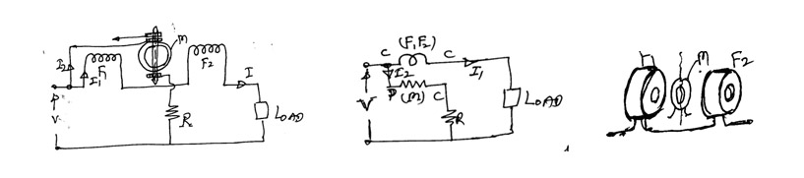
In this type there will not be any permanent magnets and there will be a pair of fixed coils connected in series when energized gives the same effect as that of the permanent magnets. In the field of these fixed coils there will be a moving coil which when energized acted upon by a torque by which it deflects

F₁ F₂: Fixed coils
M: Moving coil
R: High resistance in series with m
I₁ : load current
I₂: current through
The two fixed coils in series act as the current coil and the moving coil in series with R act as the potential coil. The moving coil is pivoted between the two fixed coils carries a current I₂ proportional to V. This current is fed to m through two springs which also provides the necessary controlling torque. This instrument can be used on both ac and dc circuits as both the coils are energized simultaneously by a common source due to which a unidirectional torque is produced.
MEGGER: It is a portable instrument used for testing the insulation resistance of a circuit and for the measurement of high resistances of the order of mega ohms.
This is a moving coil type of instrument having two coils rigidly connected to each other with their planes set at right angles to each other. These two coils are under the field of a permanent magnet and there coils are energized by a permanent magnet hand driven dc generator as shown in fig.

C = Control coil. D = Deflecting coil. Rc = Control coil series resistance.
RD = Deflecting coil series resistance. G = Permanent magnet hand driven dc generator
X-X = Test terminals across which the test specimen is connected.
When the hand driven generator is rotated it is capable of giving voltages up to 1000V, and this voltage is applied across the control coil circuit and the deflecting coil circuit produces a torque which mainly depends on the continuity provided by the deflecting coil circuit. The test specimen is connected in series with the deflecting coil and if the specimen is healthy (perfect) there will be no current and hence no torque and if it is faulty there will be a current and there will be a torque which makes the pointer to deflect which moves over the scale.

ELE-15/25. BASIC ELECTRICAL ENGINEERING

CHAPTER-I ELECTROMAGNETISM.
Faraday’s Law, Lenz’s Law, Fleming’s rules, statically and dynamically induced EMF, concept of self and mutual inductance, energy stored in magnetic field.
…………………………………………………………………………………………..
Objectives- To learn about magnetism and Electromagnetism which is the
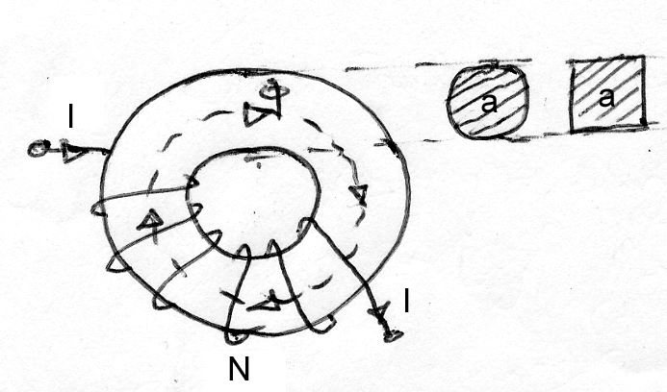
pre requisite for studying the machine theory.
To start with we should know the basics of magnetic circuits.
- What is a Magnetic circuit?
A circuit followed by magnetic lines of force (flux) is
defined as a magnetic circuit.
- What is the Magnetic flux?
It is the invisible lines of force which moves from North pole to South pole outside the magnet and vice- versa inside the magnet. Magnetic flux is denoted by the symbol and measured in Weber’s. (Wb).
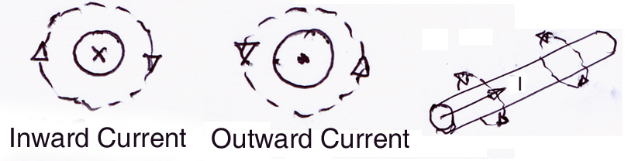
- What is the Magnetic Field?
It is defined as the region around which the
Magnetic flux acts.
- What is the Magnetic Flux Density?
It is defined as the magnetic flux passing through a unit cross section; this is denoted by the symbol B and measured in Tesla (wb/m²)
- Define Magneto Motive Force
It is the cause for the establishment of magnetic flux in a magnetic circuit or it
is the force required to drive flux through a magnetic circuit. Therefore when N number of coils is supplied with I amperes of current there will be an mmf of NI ampere turns.
- What is reluctance?
Reluctance is a kind of opposition to the establishment of magnetic flux in a circuit, just like resistance in an electric circuit.
The reluctance is S= l/ aμ₀μ_{r,} μ₀₌ Permeability of free space= 4π.10⁻⁷
μ_{r=} Relative permeability =1 for air and other non magnetic materials.
- What is Magnetic Field Intensity? It is defined as the mmf required per unit length of the magnetic circuit, and is denoted by the symbol H with unit Ampere turns per meter.
Mmf, Flux and Reluctance are related as,
MMF= (Flux) x (Reluctance)
With this basics we go further towards the Electromagnetism
Electromagnetism is a concept between Electricity and Magnetism and vice
versa.
- When ever electric current flows through a conductor, magnetic field is set up around the conductor all along its length and the flux lines are in the form of concentric circles around the conductor and the direction of the field depends on the direction of the electric current in the conductor.
- Magnetic field strength is proportional to the current and is stronger near the conductor.

Faraday’s Laws:
1st law: Whenever magnetic flux linking with a coil changes with time an emf is induced in that coil or whenever a moving conductor cuts the magnetic flux, an emf is induced in the conductor.
2nd law: The magnitude of the induced emf is equal to the product of the number of turns of the coil and the rate of change of flux linkage.
Lenz’s law: The direction of the induced emf by electromagnetic induction is in a direction to oppose the main cause producing it.
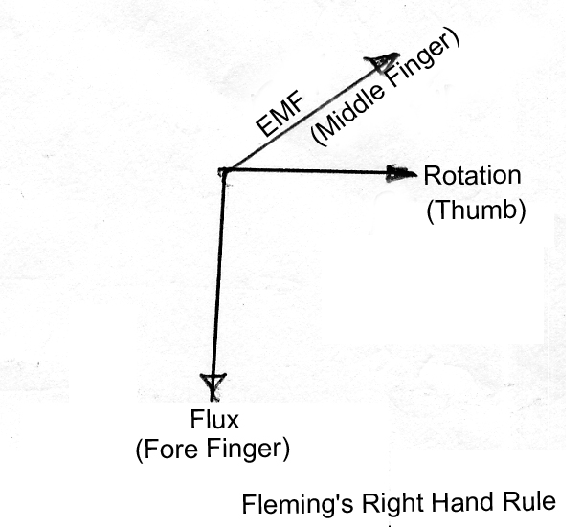
Fleming’s rules:
- Fleming’s Right hand rule: This rule helps in deciding
the direction of the induced emf.
  - Hold the right hand thumb, fore finger and the middle
finger set at right angles to each other and the thumb points
the direction of the motion of the conductor and the fore finger
points the direction of the field and the middle finger points the direction of the induced emf.
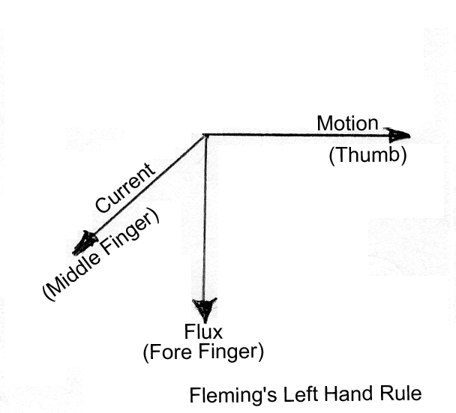
- Fleming’s Left hand rule: This rule helps in deciding the direction of force acting on a conductor.
  - Hold the left hand thumb, fore finger and the middle finger
set at right angles to each other and the thumb points the
direction of the force acting on the conductor and the direction
of the fore finger points the direction of the magnetic field and
the middle finger points the direction of the current in the conductor.

Induced EMF:
The induced emf in a coil is due to the relative flux cut by it and is of two ways.
- The coil is moved/rotated under a steady magnetic field- called the dynamically induced emf. E= BlvSinθ volts/coil side, where B is the flux density in Tesla, l the active length of each coil side in meters, v the velocity withn which the coil is rotated under the magnetic field, and θ is the angle between the direction of the magnetic flux and the direction of the movement of the coil.
- The coil is stationary and magnetic flux linking is changing with time-called the statically induced emf.
E = N dφ/dt volts
Self inductance: (L Henry): It is defined as the property of a coil to oppose any change in current.
OR It is the property of a coil to induce an emf in it when there is a change in current with time.
E= L di/dt volts

OR It is the property of a coil to store energy in a magnetic field.
Energy= ½ LI² Joules.
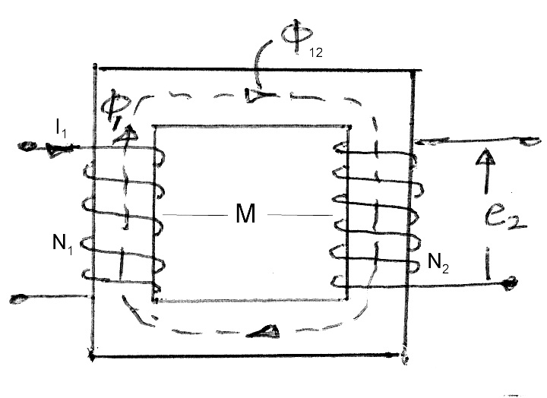
OR Self inductance is also defined as the change in flux linkage per unit ampere of current change in it.
L= N dφ /di from which we write that L=N²/S
Mutual Inductance( M Henry): It is the property of
a coil by which an emf will be induced in it when there
is a change in current in the other neighboring coil wound
on the same core.

e₂=M di₁/dt induced emf in the second coil due to a change in the current in the first coil.
Relationship between Self and Mutual inductance:
The self inductance and mutual inductance between the two coils are related as
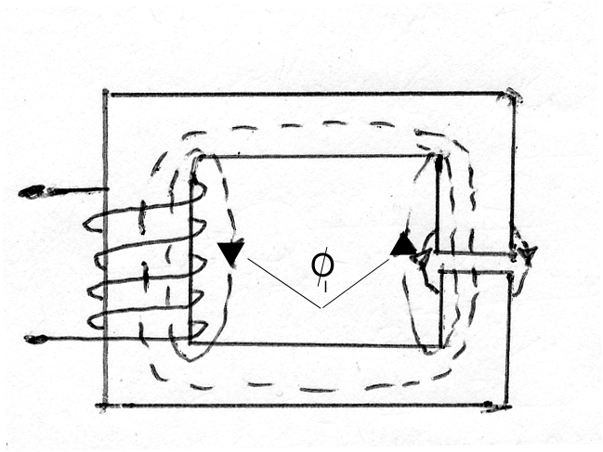
M=k√(L₁.L₂), where k is the coefficient of coupling.
Leakage flux(Φ_{l}): It is defined as the lines of force that are
following an unwanted path.
Leakage factor(λ): It is the ratio of the total flux to the
useful flux, and the value is always greater than unity.

Coupling Coefficient(k): It is the ratio of the mutual flux to the total flux and the value is always less than unity.
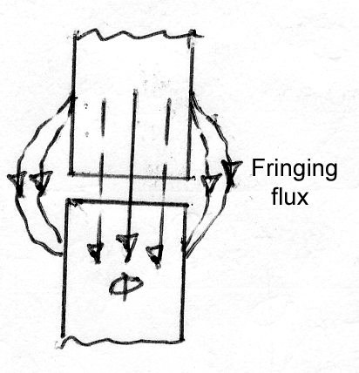
Fringing flux: The flux lines when crossing the air
gap have the tendency to bulge out, there by increasing
the flux area and resulting in the reduction of the flux
density.
Expression for the energy stored in a magnetic field.
Let the current through a coil of constant inductance of L henrys growa at a uniform rate from zero to I amperes in time t seconds. Then the average value of the current is (½)I ampere and the emf induced in the coil is (L.I/t) volts. The power absorbed by the magnetic field associated with the coil is the product of the current and the component of the applied voltage is
(1/2)I.(LI)/t watts
and the total energy absorbed by the magnetic field is the product of the average power and time.

Therefore, Energy= (1/2)I.(LI)/t .(t) = ½ LI² Joules.

Force acting on a current carrying conductor.

Whenever a current carrying conductor is subjected to a steady magnetic field there will be a force on the conductor as per Fleming’s left hand rule, and is given by F=B I l Sinθ Newtons. Where I is the current through the coil in amperes, and other terms are the same as mentioned earlier.

Questions and Problems:

- Calculate the inductance and the energy stored in the magnetic field of a air-core solenoid 100 cm long, 5 cm diameter and wound with 1000 turns, if it is carrying a current of 10 Amp.
- An iron ring with a mean circumference of 140 cm and cross sectional area of 12cm² is wound with 500 turns of wire. When the exciting current is 2 A the flux is1.2 mwb. What is the relative permeability of iron.
- Two coupled coils of self inductance 0.8H and 0.2H have a coefficient of coupling 0.9. Find the mutual inductance and the turns ratio.
- Derive and expression for the energy stored in a magnetic field.
- State and explain Lenz’s law.
- Explain the difference between the self and mutually induced emf.
- An iron cored solenoid has a length of 50 cm and a diameter of 2cm. Calculate its inductance if it has 500 turns and also find the energy stored in it if the current rises from zero to 10 amps.
- Mention the three methods used to link conductors with flux to get induced emf. Name the machine for which each is applicable.
- The winding of an electromagnet is wound with 96 turns and has a resistance of 50 ohms. The exciting voltage is 250 volt and the flux linking the coil is 5 mwb. Find the energy stored in the magnetic field. Then if the current is reversed in 0.1sec, what emf is induced in the coil?
- A conductor carries a current of 800 A at right angles to a magnetic field having a flux density of 0.5T. Calculate the force on the per meter length of the conductor.
- Explain the following:
  - Faraday’s laws of electro magnetic induction.
  - Lenz’s law.
  - Fleming’s right hand rule.
  - Fleming’s left hand rule.
- A coil of 300 turns wound on a core of non magnetic material has an inductance of 10 mH. Calculate i) the flux produced by a current of 5A,
ii) average value of the emf induced when a current of 5 A is reversed in 8
milliseconds.
- Two coils ‘A’ and ‘B’ are wound on the same magnetic core. There are 500 turns on ‘A’ and 3000 turns on ‘B’. A current of 5A in ‘A’ produces a flux of 600 milli webers in the core. If this current is reversed in 0.02 sec, calculate the emf induced in the coil ‘B’.
- A square coil of 20 cm side with 100 turns is rotated in a magnetic field at a velocity of 600 rpm. The flux density is 0.8 wb/m² . Calculate the emf induced when the coil plane is at (i) 90⁰ to the field, (ii) 60⁰ to the field
and (iii) in the plane of the field.
- What effect occurs when a straight conductor carrying a current is placed in a magnetic field perpendicular to the direction of the field? Explain this action by two elementary laws of magnetism. What is the effect of reversing the current in the conductor?

- State a convenient rule by which the relation among the direction of the current, the direction of the field, and the direction of the force can be determined. What another simple method enables one to determine this relation?
- Show that a coil carrying current when placed in a magnetic field develop a torque. In what position of the coil is the torque a maximum? When it is zero? If continuous rotation is desired, what change in the connection to the coil should be made when the torque reaches zero value?

- Fundamentally, upon what two quantities does the speed of the motor depend? Derive the equation which gives the speed in terms of terminal voltage, armature resistance drop, and the flux per pole.
- When load is applied to a motor what is its first reaction? With the shunt
Motor, how does this reaction affect the counter emf ? The current to the armature?
- How does the flux in series motor vary with the load current? Show the relation of internal torque to load current, assuming no saturation in the magnetic circuit. Show the relation of speed to load current. What precautions should be taken when the series motor is being installed for industrial drives?
- In what way do the windings of a compound motor differ from those of a shunt motor and a series motor? In what two ways, with respect to the shunt winding, may the series winding be connected?
- Discuss the speed characteristic and torque characteristic of the cumulative-compound motor. What is the advantage of this motor over the series motor?
- Why is a starting resistance necessary for d.c. motors? With the shunt motor, in what circuit the starting resistor is connected? Why should it not be connected in the line?
- The resistance of the armature of a 25-hp 240-volt shunt motor is 0.083 ohm. When connected to a 240-volt supply the armature develops a counter emf of 232.8-volts. Determine: (a) armature current; (b) armature current when connected across same power supply while stationary; (c) counter emf when armature current is 110 amperes.
- A 23-volt 4-pole 15 hp shunt motor has 702 conductors connected for simplex wave and its resistance is 0.252 ohm. The flux per pole is 7.65 milliwebers and the armature current is 60-Amp. Determine speed of armature.
- A four pole d.c. shunt motor has 456 surface conductors connected in simplex wave. The flux is 2.41 milliwebers per pole (a) Determine the counter emf when the speed is 1500 rpm. The armature resistance is 0.2 ohm. (b) Determine the terminal voltage when armature current is 60-amp if the speed and flux remain constant.
- A 60-hp, 250-volt, 1200 rpm shunt motor takes 214 amp at 250 volts. The field current is 1.05 amp, and the combined total armature resistance is 0.039 ohm. The motor speed when running light is 1200 rpm, and the line current is 8.6 amp. Determine the internal power and torque developed.
- A 25-hp, 250-volt d.c. series motor has its armature aand series field resistance of 0.12 ohm and 0.10 ohm respectively. When the motor takes 85 amp, the speed is 600 rpm. Determine the speed when the current is (a) 100 amp, (b) 40 amp. Assume saturation curve is a straight line, and neglect armature reaction.
- A 6 pole d.c. generator runs at 850 rpm, and each pole has a flux of 0.2 milliwebers. If there are 150 conductors in series between each pair of brushes, what is the value of the generated emf.?

- A 2240-volt shunt motor has a field resistance of 400 ohm and an armature resistance of 0.1 ohm. The armature current is 50 amps, and the speed is 900 rpm. Assuming a straight line magnetization curve, calculate (a) the additional resistance in the field to increase the speed to 1000 rpm for the same armature current, and (b) the speed with the original field current and an armature current of 200 amps.

Typical Questions of Basic Electrical Engineering.
- Define the coefficient of inductance of a magnetic circuit and show that it is
proportional to the square of the magnetizing turns and inversely to the
reluctance.
Define the terms “Magneto motive force”, “Magnetic Flux” and “Magnetic Reluctance” and prove the relation which holds between these quantities for a magnetic circuit.
- Two coils have a coupling coefficient k=0.85 and coil 1 has 250 turns. With a current i₁=2A in coil 1, the total flux is 0.3 wb. When i₁ is reduced linearly to zero in two milliseconds the voltage induced in coil 2 is 63.75 volts. Find L₁, L₂, M and N_{2.}
- Two coupled coils with turns N₁=100 and N₂=800 have a coupling coefficient
of 0.85. With coil 1 open and a current of 5 amperes in coil 2, the flux Ф₂ is 0.35 mwb. Find L₁, L₂ and M.

THREE PHASE ALTERNATORS.
(SYNCHRONOUS GENERATORS)
(THREE PHASE A.C. GENERATORS).
Electric power is generated using three phase alternators.

Principle: Whenever a coil is rotated in a magnetic field an EMF will be induced in the coil. This is called the dynamically induced EMF.

Alternators are also called as Synchronous Generators due to the reason that under normal conditions the generator is to be rotated at a definite speed called “SYNCHRONOUS SPEED”, Ns R.P.M. in order to have a fixed frequency in the output EMF wave.

Ns is related with the frequency as Ns = 120f / P, where f is the frequency and P is the
total number of poles.

The following table gives the idea of the various synchronous speeds for various numbers of poles for the fixed frequency of 50 Hz.

P | 2 | 4 | 6 | 8 | 10 | 12 | 16 | ……….
Ns rpm | 3000 | 1500 | 1000 | 750 | 600 | 500 | 375 | ……….

TYPES AND THEIR CONSTRUCTION:

Their two basic parts in an alternator: (i) Stator, (ii) Rotor.
Stator is the stationary part and Rotor is the revolving part.
There are two possibilities that (i) The armature can be the stator and the field system can be the rotor, and (ii) The armature can be the rotor and the field system be the stator. In practice large alternators are of the first type where in the stator is the armature and the rotor is the field system. And this type is called the “REVOLVING FIELD TYPE”.
Revolving field types are preferred due to the following reasons:
- More conductors can be easily accommodated and with these high voltage and higher power capacity
can be achieved.
- Armature conductors can be easily braced over a rigid frame.
- It is easier to insulate a stationary system.
- Cooling of the conductors will be very effective with proper cooling ducts / vents in the stationary part.
- Power can be tapped easily with out any risk from the stationary part through terminal bushings.
- The armature conductors are totally free from any centrifugal force action which tends to drag the conductors out of the slots.

CONSTRUCTION:

Revolving field type alternators are further classified into two types:
- Salient pole type, (ii) Non-salient pole type or Cylindrical rotor type.

Figs. (a), (b) and (c) shows the constructional features of the Alternator. Fig. (a) represents the stator, the core of which is made of steel laminations with slots cut in its inner periphery and all the stator stampings are pressed together and are fixed to the stator frame. Three phase windings are accommodated in these slots. These coils are identical to each other and are physically distributed such that they are displaced from each other by 120 degrees as shown in fig. (d).
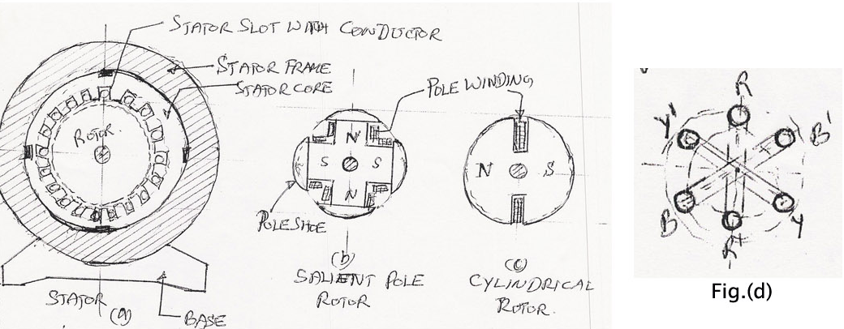

Fig. (b) represents the structure of a salient pole rotor where the poles are of projected type and are mounted on a spider and the field or the pole windings are wound over the pole core as shown. This type is preferred where the running speeds are low. Fig.(c) represents the structure of a non-salient pole rotor where the overall structure is like a cylinder having 2 or 4 poles. This type is preferred where the running speeds are very high.

The armature windings in the stator are made of copper and are normally arranged in two layers and are wound for lap or wave depending on the requirements and are usually connected in star with the neutral terminal brought out.
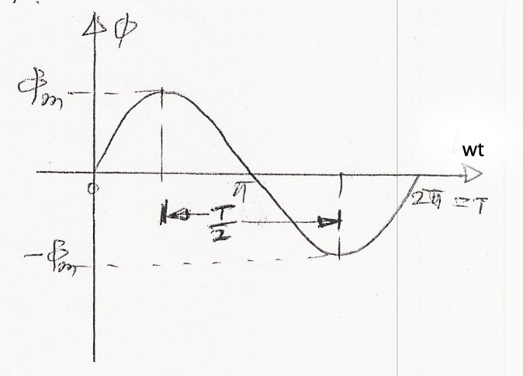
EMF Equation:

Let P be the total number of poles, Ns be the synchronous speed, f be the frequency of the induced EMF and the flux Φ considered to be sinusoidally distributed.
As we know that the induced emf is due to the rate of change of flux cut by coils, the average induced emf in Tph number of turns is

Eavg = Tph dΦ / dt volts.

For a flux change from Φm to Φm is d Φ = 2 Φm in time dt= T / 2 seconds,
The average induced Emf = Tph. 2 Φ m / ( T/2 ) = 4 Tph .f. m volts.
For a sine wave we know that the form factor is of value 1.11= Erms / Eavg.
Therefore, Erms = 1.11.Eavg.
Erms = 4.44 f Φm Tph volts per phase. . . . . . . . . . .(1)

If the armature windings are connected in star the line emf is El = 3 Ephase.
If the armature windings are connected in delta the line emf is the phase emf itself.
Equation (1) represents the theoretical value of the induced em f in each phase but in practice the
Induced emf will be slightly less than the theoretical value due to the following reasons:

- The armature windings are distributed throughout the armature in various slots and this is accounted by a factor called the “Distribution factor” Kd and is given by

Kd = (Sin(mα / 2) / mSin(α / 2)), where m is the number of slots per pole peer phase
and α is the slot angle.
α = 180⁰ / no. of slots per pole.
(ii) The span of the armature coil is less than a full pitch – This is done deliberately to eliminate some unwanted harmonics in the emf wave, this fact is accounted by a factor called the coil span factor or the pitch factor, Kp and is given by

Kp = Cos (β / 2), where β is the angle by which the coils are short chorded.

The modified Emf equation with these two factors taken into account will be

E = 4.44 Kd.Kp..f Tph volts per phase.

The product of K_{d} and K_{p} is called as the winding factor Kw .which is of value around 0.95.

VOLTAGE REGULATION:
The voltage regulation of an alternator is defined as the change in the terminal voltage between no load and full load at a specified power factor, without any change in the speed and excitation.

(No load terminal voltage – Full load terminal voltage)
% Voltage regulation = --------------------------------------------------------------------- x 100
Full load terminal voltage
E – V
% Voltage regulation = -------- x 100
V

The idea of voltage regulation is necessary to judge the performance of an alternator. Lesser the value of the regulation better will be the load sharing capacity at better efficiency.

PROBLEMS:

- The stator of a three phase, 8 pole, 750 rpm alternator has 72 slots, each of which having 10 conductors. Calculate the RMS value of the emf per phase if the flux per pole is 0.1 wb and the winding factor is 0.96. Also find the line Emf if the windings are connected in (i) Star, and (ii) Delta.
- A three phase star connected alternator driven at 900 rpm is required to generate a line voltage of 460 volts at 60 Hz on open circuit. The stator has 2 slots per pole per phase and 4 conductors per slot. Calculate (i) the number of poles, (ii) the useful flux per pole.
- A 4 pole, three phase, 50 Hz, star connected a.c. generator has 24 stator slots. Find the number of conductors per slot if the flux per pole is 62 mwb and the terminal voltage is 1100 volt. Assume full pitch coils.
- A 16 pole star connected alternator has 144 slots and 10 conductors per slot. The flux per pole is 30 mwb and the speed is 375 rpm. Find the frequency, the phase and line emf’s.
- Find the number of armature conductors in series per phase required for the armature of a three phase
50 Hz 10 pole alternator with 90 slots. The winding is star connected to give a line emf of 11 Kv. The flux is 0.16 wb. Also find the voltage regulation if the terminal voltage on full load is 11.2 kv.
- A three phase 10 pole star connected alternator runs at 600 rpm. It has 120 stator slots with 8 conductors per slot. Determine the phase and line emf’s if the flux per pole is 56 mwb.
- Calculate the phase emf induced in a 4 pole, three phase, 50 Hz star connected alternator with 36 slots and 30 conductors per slot. The flux per pole is 0.05 wb. Given the winding factor as 0.95.
TRANSFORMERS

TRANSFORMER is a static device which transfer electric energy from one electric circuit to another at any desired voltage with out any change in frequency.

PRINCIPLE:- A transformer works on the principle of mutual induction. “Whenever a change in current takes place in a coil there will be an induced emf in the other coil wound over the same magnetic core”. This is the principle of mutual induction by which the two coils are said to be coupled with each other.

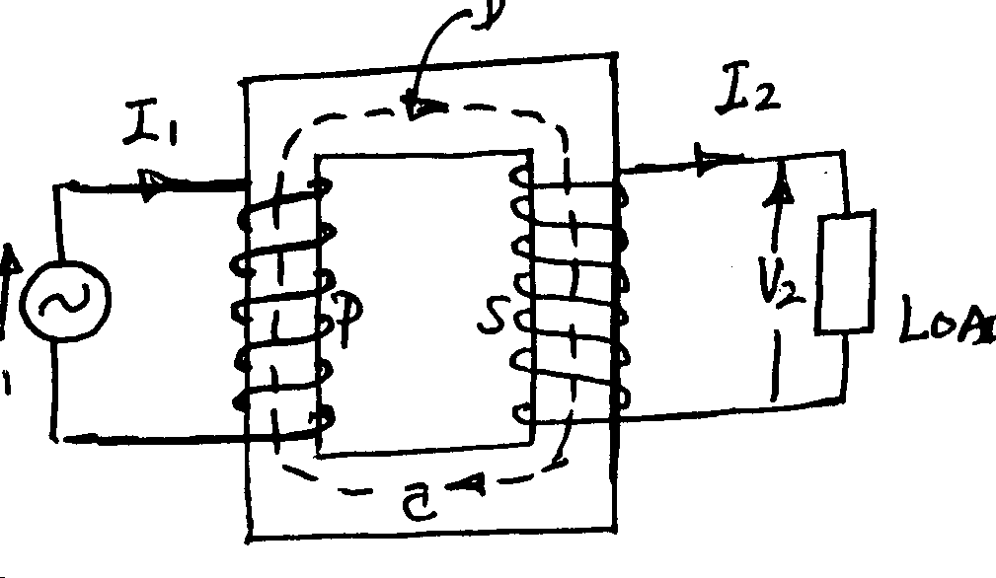

V₁
Load

Fig.1
The fig1 shows the general arrangement of a transformer. C is the iron core made of laminated sheets of about 0.35mm thick insulated from one another by varnish or thin paper. The purpose of laminating the core is to reduce the power loss due to eddy currents induced by the alternating magnetic flux. The vertical portions of the core are called limbs and the top and bottom portions are called the yokes. Coils P and S are wound on the limbs. Coil P is connected to the supply and therefore called as the primary, coil S is connected to the load and is called as the secondary.
An alternating voltage applied to P drives an alternating current though P and this current produces an alternating flux in the iron core, the mean path of the flux is represented by the dotted line D. This flux links with the coil S and thereby induces an emf in S.

TYPES AND CONSTRUCTION OF TRANSFORMERS
There are two basic circuits in a transformer

- Magnetic circuit 2) Electric circuit

The core forms the magnetic circuit and the electric circuit consists of two windings primary and secondary and is made of pure copper. There are two types of single phase transformers.

a) CORE TYPE b) SHELL TYPE

Figs (a) and (b) shows the details of the elevation and plan of a core type transformer. The limbs are wound with half the L.V. and half the H.V. windings with proper insulation between them. The whole assembly taken inside a steel tank filled with oil for the purpose of insulation and cooling.

CORE TYPE TRANSFORMER.
In the core type the core is surrounded by the coils but in the shell type the core is on the either side of the coils. There are three limbs and the central limb is of large cross section than that of outer limbs, and both the LV and HV windings are wound on the central limb and the outer limb is only for providing the return path for the flux.
The windings are of concentric type (i.e. LV on which the HV windings) or Sandwich type.
The core is made of very thin laminations of high grade silicon steel material to reduce the eddy current loss and Hysterisis losses in the core.

SHELL TYPE TRANSFORMER.

1, 1 – Outer limbs, 4 – L V winding
2 – Central limb, 5 – Insulation between L V and H V windings.
3 – Insulation between L V and Core. 6 – H V winding. 7 – End insulation

In the shell type transformers the core is of different type having three limbs with the central limb of larger cross section compared to the two outer limbs and carries both the L V and H V windings wound over each other with proper insulation between them. The entire assembly is immersed in a steel tank filled with oil for the cooling purpose.

EMF EQUATION:
Priciple:- Whenever a coil is subjected to alternating flux, there will be an induced emf in it and is called the statically induced emf $e=\frac{\text{Nd}φ}{\text{dt}}$

Let N₁, N₂ be the no. of turns of the primary and secondary windings, E₁, E₂ the induced emf in the primary and secondary coils. $φ$ be the flux which is sinusoidal f be the frequency in Hz

Figure showing the sinusoidally varying flux of peak value Ф_{m} .

Whenever a coil of N no- of tunes are linked by a time varying flux $φ$, the average emf induced in this coil is
$e=\frac{\text{Nd}φ}{\text{dt}}$
As the flux is sinusoidal the change in flux from +$φ$_{m} to -$φ$_{m} is d$φ$ = 2$φ$m, and this change takes place in a duration dt = T/2 seconds.
The average induced emf in these N number of turns is

E_{avg =} N.d$φ$/dt = N.2$φ$_{m} / (T/2) = 4$φ$_{m}N/T = 4f$φ$_{m} N volts (as f =1/T)

We know that the Form factor of a pure sine wave F.F. = E_{rms}/E_{avg} = 1.11

Therefore, E_{rms} = 1.11 E_{avg.}

= (1.11) (4f$φ$_{m} N) = 4.44 f$φ$_{m} N volts.

In the primary coil, N = N₁, E1 = 4.44f$φ$_{m} N₁ volts

In the secondary coil, N = N₂ , E₂ = 4.44f$φ$_{m} N₂ volts

TRANSFORMATION RATIO:
It is defined as the ratio of the secondary induced emf to the primary induced emf.
Therefore, E₁ / E₂ = N₁ / N₂ = K
For an ideal (loss free ) transformer, the input power is equal to the out put power.
Therefore E₁I₁ = E₂I₂, from which, E₂/E₁ = I₁/I₂
Also the induced emf per turn is same for both the primary and secondary turns.
If the value of the transformation ratio K>1, then it is a step up case.
If the value of the transformation ratio K<1, then it is a step down case.
If the value of the transformation ratio K=1, then it is a one:one transformer.

LOSSES AND EFFICIENCY: There a two types of power losses occur in a transformer

1) Iron loss 2) Copper loss

1) Iron Loss: This is the power loss that occurs in the iron part. This loss is due to the alternating frequency of the emf. Iron loss in further classified into two other losses.

a) Eddy current loss b) Hysterisis loss

a) EDDY CURRENT LOSS: This power loss is due to the alternating flux linking the core, which will induced an emf in the core called the eddy emf, due to which a current called the eddy current is being circulated in the core. As there is some resistance in the core with this eddy current circulation converts into heat called the eddy current power loss. Eddy current loss is proportional to the square of the supply frequency.

b) HYSTERISIS LOSS: This is the loss in the iron core, due to the magnetic reversal of the flux in the core, which results in the form of heat in the core. This loss is directly proportional to the supply frequency.

Eddy current loss can be minimized by using the core made of thin sheets of silicon steel material, and each lamination is coated with varnish insulation to suppress the path of the eddy currents.

Hysterisis loss can be minimized by using the core material having high permeability.

2) COPPER LOSS: This is the power loss that occurs in the primary and secondary coils when the transformer is on load. This power is wasted in the form of heat due to the resistance of the coils. This loss is proportional to the sequence of the load hence it is called the Variable loss where as the Iron loss is called as the Constant loss as the supply voltage and frequency are constants

EFFICENCY: It is the ratio of the out put power to the input power of a transformer
Input = Output + Total losses
= Output + Iron loss + Copper loss

Efficiency =
$$\begin{aligned}η=\frac{\text{outputpower}}{\text{outputpower}+\text{Ironloss}+\text{copperloss}} \\ =\frac{V_{2}I_{2}\text{cos}φ}{V_{2}I_{2}\text{cos}φ+W_{\text{eron}}+W_{\text{copper}}}\end{aligned}$$

Where, V₂ is the secondary (out put) voltage, I₂ is the secondary (out put) current and
cosФ is the power factor of the load.
The transformers are normally specified with their ratings as KVA,
Therefore,

Efficiency= (KVA)(10³) cosΦ
----------------------------------------------
(KVA)(10³) cosΦ + W_{iron} + W_{copper}

Since the copper loss varies as the square of the load the efficiency of the transformer at any desired load x is given by

Efficiency= x. (KVA)(10³) cosΦ
-------------------------------------------------
x. (KVA)(10³) cosΦ + W_{iron} + (x)² W_{copper}

where W_{copper} is the copper loss at full load

W_{copper} = I²R watts

CONDITION FOR MAXIMUM EFFICIENCY:

In general for the efficiency to be maximum for any device the losses must be minimum. Between the iron and copper losses the iron loss is the fixed loss and the copper loss is the variable loss. When these two losses are equal and also minimum the efficiency will be maximum.

Therefore the condition for maximum efficiency in a transformer is

Iron loss = Copper loss ( which ever is minimum)

VOLTAGE REGULATION:

The voltage regulation of a transformer is defined as the change in the secondary terminal voltage between no load and full load at a specified power factor expressed as a percentage of the full load terminal voltage.

(percentage (No load secondary voltage)-(Full load secondary voltage)
voltage = ---------------------------------------------------------------------------x 100
regulation) (Full load secondary voltage)

Voltage regulation is a measure of the change in the terminal voltage of a transformer between No load and Full load. A good transformer has least value of the regulation of the order of ±5%

Problems:

- The required No load ratio of a single phase 50Hz, core type transformer is 6000/150v. Find the number of turns per limb on the high and low voltage sides if the flux is to be 0.06 wb.

- A 125 KVA, single phase transformer has a primary voltage of 2000 v at 60
Hz. If the number of turns of the primary is 182 and secondary has 40 turns find (i) the secondary no load voltage (ii Flux in the core (iii) the full load primary and secondary currents.

- A 600 KVA, single phase transformer has an efficiency of 92% both at full load and half full load at unity power factor. Determine the efficiency at 75% of full load and 0.9 power factor.
- A 50KVA transformer has an efficiency of 98% at full load, 0.8 p.f. and an efficiency of 96.9% at 1/4th full load, u.p.f. Determine the iron loss and full load copper loss.

- In a 50KVA, 2000/200 v single phase transformer the iron loss and full load copper losses area 700 w and 1000 W respectively. Calculate the efficiency of the transformer on full load and at half full load. The p.f. of the load is 0.75 lag.

- A 5 KVA, 200/100 v, single phase, 50Hz transformer has a rated secondary voltage at full load. When the load is removed the secondary voltage is found to be 110 v. Determine the percentage voltage regulation.

- A single phase transformer has 400 primary and 1000 secondary turns. The net cross sectional area of the core is 60 cm². If the primary winding is connected to a 50Hz supply at 500v, calculate (i) the peak value of the flux density in the core (ii) the voltage induced in the secondary winding.

